# Appendix 2.1 Gulf of Alaska Pacific cod assessment models for Plan Team consideration, September 2021

Steven Barbeaux, Ben Laurel, Mike Litzow, and Ingrid Spies

Alaska Fisheries Science Center

National Marine Fisheries Service

National Oceanic and Atmospheric Administration

7600 Sand Point Way NE., Seattle, WA 98115-6349

## Introduction

In this document the authors present a series of bridged models and seek advice on which models the Plan Team would like presented in November. The authors would also like advice on what objective model selection criteria the Plan Team would suggest be presented to aid in model evaluation and selection for November.

For this year we explore five changes to the model from the 2020 reference model (Model 19.1, Barbeaux *et al.* 2020) that result in nine bridged models (Table 1). First we look at the inclusion of a beach seine age-0 index of abundance to the model; second, we examine environmental links on growth, natural mortality, and recruitment; third we examine changing the natural mortality block to 2015-2020; and finally we examine tuning the model indices to the RMSE and the length composition data using the Francis method. The addition of the age-0 beach seine data as a recruitment index was provided as an improvement to help inform recruitment estimates. Previous models used to manage this stock have had few data to inform abundance at ages younger than 3. The set of environmentally linked models demonstrate issues with fitting these links in single species stock assessment models and the difficulty in model selection where improvements are minimal. The tuned models were presented to demonstrate the sensitivity of the models to differences in data weighting.

Adding environmental links to the base model adds complexity to the models and makes assumptions about the processes that impact the annual variability of the stock that may not yet be well established in the literature. The improvements to the tactical model in all cases were at best minor while changes to the management advice resulting from the models were in some cases substantial. The authors wish to continue to work on these models and present a set of these for November, but are reluctant to recommend any of them for management of the stock at this time.

## Environmental Data

### Laurel and Litzow age-0 index

Beach seine sampling of age-0 cod was conducted at two Kodiak Island bays during 2006-2021 and an expanded survey was conducted during 2018-21 at 13 additional bays on Kodiak Island, the Alaska Peninsula, and the Shumagin Islands (n = 3 - 9 fixed stations per bay, 95 total stations). Sampling occurs during July and August (days of year 184-240), within two hours of a minus tide at the long-term Kodiak sites, and within three hours of a low tide at the expanded survey sites. At all sites, a 36 m long, negatively buoyant beach seine is deployed from a boat and pulled to shore by two people standing a fixed distance apart on shore. Wings on the seine (13 mm mesh) are 1 m deep at the ends and 2.25 m in the middle with a 5 mm delta mesh cod end bag. The seine wings are attached to 25 m ropes for deployment and retrieval from shore. The seine is set parallel to and ~ 25 m, making the effective sampling area ~ 900 m 2 of bottom habitat.

A model-based index of annual catch per unit effort (CPUE) for age-0 cod was used to resolve inter-annual differences in sampling across different bays and different days of the year. Specifically, a Bayesian zero-inflated negative binomial (ZINB) model was used invoking year as a categorical variable, day of year as a continuous variable, and site nested within bay as a group-level (random) effect. The day of year effect was modeled with thin plate regression splines to account for non-linear changes in abundance through the season and the number of basis functions was limited to 3 to avoid over-fitting data. This model was fit using Stan 2.21.0, R 4.0.2 and the *brms* package (Carpenter et al. 2017, Buerkner 2017, R Core Team 2021). The beach seine age-0 CPUE index shows the large 2012 year class and subsequent drop in CPUE for 2013-2016, larger recruitment in 2017 and 2018, a drop again in 2019, and then large 2020 year class (Table 2) correlating positively with Model19.1 recruitment estimates although not statistically significant (R2 = 0.27).

### CFSR bottom temperature indices

The Climate Forecast System Reanalysis (CFSR) is the latest version of the National Centers for Environmental Prediction (NCEP) climate reanalysis. The oceanic component of CFSR includes the Geophysical Fluid Dynamics Laboratory Modular Ocean Model version 4 (MOM4) with an iterative sea-ice (Saha et al., 2010). It uses 40 levels in the vertical with a 10-meter resolution from surface down to about 262 meters. The zonal resolution is 0.5° and a meridional resolution of 0.25° between 10°S and 10°N, gradually increasing through the tropics until becoming fixed at 0.5° poleward of 30°S and 30°N.

To make the index the CFSR reanalysis grid points were co-located with the AFSC bottom trawl survey stations. The co-located CFSR oceanic temperature profiles were then linearly interpolated to obtain the temperatures at the depths centers of gravity for 10 cm and 40 cm Pacific cod as determined from the AFSC bottom trawl survey. All co-located grid points were then averaged to get the time series of CFSR temperatures over the period of 1979-2020 (Table 3).

### Sum of annual marine heatwave cumulative intensity index (MHCI)

The daily sea surface temperatures for 1 January 1981 through 31 December 2020 were retrieved from the NOAA High-resolution Blended Analysis Data database (National Oceanic and Atmospheric Administration, 2017) and filtered to only include data from the central Gulf of Alaska between 145°W and 160°W longitude for waters less than 300 m in depth. The overall daily mean sea surface temperatures were then calculated for the entire region. These daily mean sea surface temperatures data were processed through the R package *heatwaveR* (Schlegel and Smit, 2018) to obtain the marine heatwave cumulative intensity (MHCI; Hobday et al., 2016) value where we defined a heatwave as 5 days or more with daily mean sea surface temperatures greater than the 90th percentile of the 1 January 1982 through 31 December 2012 time series. The MHCI were then summed for each year to create an annual index of MHCI, summed for each year for the months of January through March, November, and December to create an annual winter index of MHCI, and summed for February and March to create an annual spawning index of MHCI (Table 3).

## Model Configurations

Except where noted below the models presented are configured the same as Model 19.1 from Barbeaux et al. (2020), the reference model used to set management advice. All ecosystem-link parameters presented are fit with uninformative uniform priors.

### AFSC longline survey catchability

For the base model an ecosystem-linked covariate on AFSC longline survey catchability has been in use since 2017 (Barbeaux et al., 2016) and will continue to be used in all of the models used in this study. Annual catchability, Qy, was modeled using a multiplicative link as:

$$log\left(Q_{y}\right)=log\left(\overline{Q}\right)e^{αf_{Jy}}$$,

where $\overline{Q}$ is the mean catchability for the AFSC longline survey for 1977 through 2020, α is the ecosystem link parameter fit with an uninformative prior, and $f_{Jy}$ is the June CFSR bottom temperature anomaly in the Central GOA in year y.

### Growth

For the base model (19.1), 21.1a, 21.1b, and 21.1c length at age, $L_{a}$, were modeled as three parameter von Bertalanffy growth models with length in June, $L_{1}$, maximum asymptotic length, L2, and growth rate, k, as:

$L_{a}={L_{2}-\left(L_{2}-L_{1}\right)e}^{-ak}$,

where a is age.

For the ecosystem-linked models 21.1d, 21.1e, 21.1f, 21.5a and 21.5b length at age for each year, $L_{ay}$, were modeled as six parameter von Bertalanffy growth modeled with annual water temperature covariates on $L_{1}$, $L_{2}$, and k as:

$$L_{ay}={L_{2y}-\left(L_{2y}-L_{1y}\right)e}^{-ak\left(e^{{φf}_{Jy}}\right)}$$

$$L_{1y}={\overline{L}}_{1}e^{\left(γ\frac{e^{\left(0.2494+0.3216\left(\overline{t}+f_{Jy}\right)-0.0069{\left(\overline{t}+f_{Jy}\right)}^{2}-0.0004{\left(\overline{t}+f_{Jy}\right)}^{3}\right)}}{e^{\left(0.2494+0.3216\left(\overline{t}\right)-0.0069{\left(\overline{t}\right)}^{2}-0.0004{\left(\overline{t}\right)}^{3}\right)}}\right)}$$

$$L_{2y}={\overline{L}}_{2}e^{υf_{Jy}}$$

where $f_{Jy}$ is the June bottom temperature anomaly in the Central GOA (described above) in year y, γ is the temperature anomaly link parameters for $L_{1}$ and an index of the ratio of the annual June temperature, $\overline{t}+f_{Jy}$, dependent juvenile growth (Laurel *et al.* 2015) for a given year over the growth in June for the mean temperature for 1982-2012, $\overline{t}$, υ is the temperature anomaly link parameter for L2, and φ the temperature anomaly link parameter for *k*.

### Natural mortality

Natural mortality in the base Model 19.1, and Models 21.1a, 21.1b, and 21.1d were fit for two time blocks, 2014-2016 and all other years, as a single non-varying parameter for all ages for each block. Natural mortality in Model 21.1c, 21.1e, and 21.1g was annually varying with a linear ecosystem-link parameter, $η$, which scaled the non-heatwave year natural mortality, $\hat{M}$, using the annual central GOA marine heatwave cumulative index (*IAy*) as:

$$M_{y}=\hat{M}+ηl_{y}$$

$$l_{y}=λ/{\left(1+e^{-ς\left(I_{Ay}-ψ\right)}\right)}$$

A logistic curve was used to convert the index forcing M to asymptote at higher index values (Table 3). Here the shape of the logistic curve including the asymptote, λ, slope, ς, and inflection point in °C days, ψ, was determined within the model iteratively and the parameters resulting in the lowest negative log-likelihood were selected for projections. The best fit model had λ at 0.65, ς = 0.005 and ψ = 400 resulting in increased natural mortality estimates for years with positive *IAy* values. Note the maximum annual marine heatwave index value in the time series was 631°C-days in 2016, well below future projected values.

For Models 21.5a and 21.5c natural mortality were fit for two time blocks, 2015-2021 and all other years, as a single non-varying parameter for all ages for each block with uninformative priors.

### Recruitment

In the base Model 19.1, Model 21.1a, and Model 21.1b recruitment by year, Ry, were modeled as:

$R_{y}=\left(R_{0}e^{ϑ}\right)e^{-0.5b_{y}σ_{R}^{2}+{\tilde{R}}_{y}}$, if y ≥ 1977 → $ϑ$ = 0, where ${\tilde{R}}_{y}=N\left(0; σ_{R}^{2}\right)$,

$R_{0}$ is the unfished equilibrium recruitment, ${\tilde{R}}_{y}$ is the lognormal recruitment deviation for year y, $σ_{R}^{2}$ is the standard deviation among recruitment deviations in log space and was fixed at 0.44, and by is a bias adjustment fraction applied during year, y (Methot Jr and Taylor, 2011). To account for an environmental regime change in 1977 (Anderson and Piatt, 1999) the parameter $ϑ$ was fit for recruitment allowing for a change in R0 prior to the regime change in 1977. Projections in the base model post-2017 assumed average recruitment for 1977-2017 for Ry.

The ecosystem-linked recruitment (Ry) in models 21.1d, 21.1e, 21.1g, 21.5a, and 21.5c were modeled as Beverton-Holt relationships with parameter ($ω$) which scaled the unfished equilibrium recruitment, $R_{0}$, using the annual spawning Central GOA marine heatwave cumulative index (Iy; described below) as:

$R_{y}=\frac{4h\left(R_{0}e^{ϑ}\right)\left(e^{ωI_{Sy}^{3}}\right){SB}_{y}}{{SB}_{0}\left(1-h\right)+{SB}_{y}\left(5h-1\right)}e^{-0.5b_{y}σ_{R}^{2}+{\tilde{R}}_{y}}$, if y ≥ 1977 → $ϑ$ = 0, where ${\tilde{R}}_{Y}=N\left(0; σ_{R}^{2}\right)$,

h is the steepness parameter, SB0 is the unﬁshed equilibrium spawning biomass (corresponding to R0), and SBy is the spawning biomass at the start of the spawning season during year y.

### Model tuning

For all models except Model 21.1g and 21.5c the models remained at the base configuration with no additional tuning. For these two models the index input variances were tuned to the RMSE and the length and age composition sample size tuned using the Francis TA1.8 method (Francis 2011).

## Results

### Beach seine index

The inclusion of the age-0 beach seine index in Model 21.1a resulted in a poorer fit for the majority of data components compared to Model 19.1 (Table 4); however, there is a reduction in the objective function for recruitment (Table 5). Comparisons of overall likelihood and marginal likelihoods are not possible given the inclusion of a new dataset/likelihood component. As one would expect the variance estimates for recruitment deviations for the years in which index data are available are lower than in the model without the beach seine index (Table 6). For 2006-2020 the mean CV for Model 19.1 was 0.25 and for Model 21.1a, with the beach seine age-0 index, was 0.19. The index RMSEs for the bottom trawl and longline survey show a reduction in fit and the Effective N for age and length compositions for all components show a slight degradation in fit from Model 19.1 to Model 21.1a.

Retrospective analysis showed both models had slight positive retrospective bias in the estimates of spawning stock biomass with the Mohn’s ρ of 0.081 for Model 19.1 and 0.087 for Model 21.1a. The Woodshole ρ and RMSE for spawning stock biomass were also similar (Table 7) with only slight differences between the two configurations. The retrospective bias for both models is considered to be within acceptable bounds.

The largest change in model results between Model 19.1 and Model 21.1a is the increase in estimates for the 2017, 2018, and 2020 year classes and slight decrease in the 2019 year class estimate (Table 6 and Fig. 2) resulting in an overall increase in 2019-2020 estimates of spawning stock biomass (Table 8 and Fig. 2) and increase in projected 2021 and 2022 spawning biomass. This increasing abundance starting in 2017 due to fit to the age-0 index and inability of the model to compensate with changing M post-2016 results in the disagreement in Model 21.1a with the recent reduction in the longline survey abundance. Model 21.1a would recommend a ~200% increase in ABC for 2022. This large increase is mostly due to a drop in the estimated unfished spawning biomass with increases in recruitment (Table 5) and an increase in the projected spawning biomass for 2022 resulting in the spawning biomass ratio being above B40% and no longer on the sloping portion of the control rule.

As Model 21.1a is configured there is disagreement between the age-0 beach seine index and all other data components. There are at least two possible reasons for this disparity 1) the beach seine survey doesn’t capture the GOA-wide trend in age-0 abundance, and/or 2) Model 21.1a with natural mortality modeled across all ages with only a block for 2014-2016 does not adequately capture survival variability between age-0 and age-3. Attempts this year at fitting annually varying age-specific M failed as there is a lack of information for the younger age classes as these younger fish are not consistently caught in the fisheries or surveys. For the remainder of the models presented we assume that the beach seine survey index captures the trend in GOA age-0 Pacific cod abundance.

### Environmentally-linked models

The three new environmental links on growth, natural mortality, and recruitment made improvements to the overall model fits over Model 21.1a as measured by full likelihood and full AIC. However the marginal likelihood (Thorson *et al.* 2019) in some cases suggest some of the changes were not true model improvements. Most of the changes made by the inclusion of the environmental links were minor in terms of fit, but some would result in substantial changes in management advice from the base model. Although the residual plots are not provided due to the volume of possible plots, they were assessed by the authors and can be made available on request for any model. For all the age and length composition data there are no severe trends in the residuals and it is very difficult to ascertain differences in model fits visually as differences were subtle. For all models presented there were no parameters near bounds and the likelihoods appear well defined with the gradient of the objective function at less than 10e-4. All models were examined by “jittering” starting parameters by 10% over 50 runs to evaluate if models had converged to local minima. All models evaluated were deemed adequate.

#### Model21.1b: SST-linked growth

The parameterization and fit of the SST-linked growth in Model 21.1b resulted in the model estimating faster growth in warm years and slower growth in cold years (Fig 3). The parameters appear to be well fit with small gradients and CVs between 0.23 and 0.28. SST-linked growth was most impactful in the age-0 fish creating a cohort effect on length in the model (Fig. 3). The addition of sea surface temperature links to growth in Model 21.1b resulted in an improvement in both length and age composition fits for likelihood and effective N (Table 4), but a degradation in the fit to all three of the survey indices. There was an overall improvement in AIC from Model 21.1a, however the marginal AIC suggests that the SST-linked growth was not a model improvement. Although the retrospective bias remains within acceptable bounds the analysis suggests a slight increase in positive retrospective bias from Model 21.1a in the spawning biomass estimates across all three measures (Table 7). Overall model results in terms of reference points and current biomass levels (Table 5 and Table 8) remain similar to Model 21.1a.

#### Model 21.1c: Annual heatwave linked natural mortality

Adding heatwave-linked natural mortality to the model made the greatest improvement to the objective function, AIC, and Marginal AIC over all of the single eco-linked changes from Model 21.1a. The environmental link parameter is well fit with low gradient and a CV of 0.10. Model 21.1c showed improvement over Model 21.1a in fits to the most recent drop in abundance in the longline survey (Figure 4), in the trawl and longline fishery length composition data, and in the beach seine index. There is a slight degradation in fit to the other data components (Table 4), however the improvement of fit to the most recent longline survey estimates were greater than the combined negative impacts to fit to the other components. Including annual heatwave index-linked natural mortality in Model 21.1c (Fig. 5) results in natural mortality peaking during heatwave years with the highest in 2016 at 0.92 and second highest in 2019 at 0.81. The retrospective analysis shows the model within acceptable bounds with a slight increase in the Mohn’s ρ, but a decrease in both the Woodshole ρ and retrospective RMSE compared to Model 21.1a.

Although the overall trend in abundance and recruitment are similar for most of the time series as are reference points between Models 21.1a and 21.1c, the management implications of the estimated drop in abundance for 2018-2020 and projections in Model 21.1c (Fig. 7) changes recommended harvest advice on ABC considerably from Model 21.1a and 21.1b with a -40% lower ABC in 2022. This difference results in an ABC nearer the Model 19.1 value (+23%). The difference from Model 21.1a is partly due to the 2022 Model 21.1c spawning biomass being estimated below B40% (Table 5) and on the slope of the control rule.

#### Model 21.1d: Spawning heatwave index linked recruitment

The spawning heatwave index linked recruitment (Fig. 6) in Model 21.1d results in a slight improvement of fit compared to model 21.1a based on a lower overall objective function and AIC estimate, however there was an increase in the marginal AIC (Table 7). Minor improvements in the objective function can be attributed to fit to the bottom trawl and longline surveys and reduction in recruitment residuals. There were minor reductions in fit to all of the age and length composition data (Table 4). Retrospective bias remained positive for all measures with a slight improvement over Model 21.1a (Table 7). Estimates for unfished biomass were within 1% of the Model 21.1a values as were the recommended ABC for 2022.

#### Model 21.1e: All three environmental links

Inclusion of all three environmental links in Model 21.1e (Table 5) results in a better fit model in regards to the objective function and AIC, however the marginal AIC was higher than Model 21.1c with just heatwave-linked natural mortality. In addition although still within generally acceptable bounds the retrospective analysis resulted in an increase in the positive bias in the model over all the other models examined for the Mohn’s ρ and retrospective RMSE (Table 7). Gradients for the environmental link parameters were all relatively low (Table 9). The ω link parameter on R0 was the least well defined with a CV of 0.38 and gradient of 0.0001. Compared to Model 21.1a, Model 21.1e improved fits to the longline and beach seine survey indices, the length and age composition data for all three fisheries, the bottom trawl survey age composition data, and the longline survey length composition data (Table 4). Recruitment residuals were improved over all of the other models assessed before tuning (Table 5).

For Model 21.1e the overall trend in abundance and recruitment are similar to the other Model 21.1 series (Fig. 1). Like model 21.1c, Model 21.1e has a drop in abundance for recent years (Fig. 7) and the projections with similar estimates of annually varying natural mortality. Model 21.1e unfished spawning biomass at 345,360 t is the lowest of the un-tuned Model 21.1 series, but is only -5% different from Model 21.1a and -6% from Model 21.1d, the highest of the series, and -16% from Model 19.1. The management implications of the estimated drop in abundance for 2018-2020 and projections in Model 21.1e (Fig. 7) changes recommended harvest advice on ABC considerably from Model 21.1a and 21.1b with a -45% lower ABC in 2022. The Model 21.1e ABC, like Model 21.1c ABC, is nearer the Model 19.1 value (+13%).

### Expanding the natural mortality block to 2015-2020

Like Model 21.1e, Model 21.5a has environmental links on recruitment and growth, but unlike Model 21.1e the mortality block first used in Model 19.1 was changed from 2014-2016 to 2015-2020 after iteratively testing combinations of M blocks (Fig. 5). Compared to Model 21.1e, Model 21.5a improves fits to all age composition data and all length composition data except the longline survey length composition and length composition data as well as the longline and beach seine surveys over Model 21.1e while degrading the fit to the bottom trawl survey index. The AIC and marginal AIC are the lowest of all un-tuned models examined for this analysis. Environmentally linked parameter estimates (Table 9) are well estimated with low gradients and relatively low CVs. The estimate for natural mortality for 1978-2014 was the lowest of all the models evaluated at 0.40 and an estimate of M for 2015-2020 at 0.72. Both the bottom trawl and base longline catchability are high for Model 21.5a at 1.359 and 1.413, respectively. The α parameter linking the longline survey catchability to the CFSR surface temperatures is substantially lower than the other non-tuned models from between 0.8 and 1.0 down to 0.5 suggesting less influence of temperature on the longline survey index estimates (Table 9). The retrospective analysis on SSB suggests an increase in the Woodshole ρ and retrospective RMSE over all other models examined (Table 7), but a slight decrease in the Mohn’s ρ compared to Model 21.1e, but still higher than other un-tuned models examined. The increased natural mortality in 2015-2020 improves the fit to the large drop in abundance estimated in the longline survey over the last 5 years while degrading the fit to the increasing biomass estimate from the 2019 bottom trawl survey (Fig. 9) making it the worst fit model to this dataset of all examined. While improving the fit to the beach seine survey Model 21.5a increased residuals to estimated recruitment over Model 21.1e.

The trends in spawning biomass and recruitment mirror the other models examined, however with the lower estimates for natural mortality and higher estimates for catchability the recruitment estimates are lower than other models as are the biomass estimates. Like the other models examined in this document Model 21.5a estimates that the lowest spawning biomass occurred in 2020 (Table 8), however spawning biomass in Model 21.5a is estimated to be below B12% in 2020 and 2021 and to remain below B20% through 2022, which would substantially change management advice for this stock compared to the other un-tuned models.

### Tuning the models

With the addition of the age-0 index we once again looked into model tuning and the use of the Dirichlet multinomial to handle data weighting for the length and age composition as recommended in Thorson et al. (2019). As in previous attempts with the GOA Pacific cod model, the model fits resulted in the ln(theta) parameters with values >15. In addition when implemented in Stock Synthesis the Dirichlet multinomial option led the models to be highly unstable and sensitivity, jitter, and retrospective runs often failed to converge making it difficult to evaluate the models even with the theta parameters fixed. In this document we chose to run two model configurations (Model 21.1g and 21.5c) with the indices tuned to the Index RMSE and the age and length composition sample sizes tuned using the Francis A1.8 method as implemented in R4SS. These models correspond with the un-tuned models 21.1e and 21.5a.

Due to differences in the multinomial sample sizes the overall likelihoods between Model 21.1g and 21.5c cannot be compared nor can they be compared with the other models presented. For both tuned models there was a reduced weight on all three survey indices with an increase in variance for all three indices and a reduction in all age and length composition sample sizes (Table 10). The effective sample size in both tuned models were substantially lower than the un-tuned models as would be expected with the lower input sample size. The increase in variance and drop in input sample size places less weight on the data components and allows the model to adhere more closely to structural assumptions such as those provided for recruitment. The model then expends less in reducing recruitment residuals where the assumptions conflict with data. Due to the higher variance for the Longline survey index in both tuned models, the environmental link parameter on catchability (α) was substantially lower (0.382 and 0.295 for Model 21.1g and Model 21.5c) than the un-tuned models (between 0.8 and 1.0 for the Model 21.1 series and 0.5 for Model 21.5a), resulting in models with less variability in the longline survey index with sea surface temperature. Similarly, the temperature growth link parameters (φ, γ, and υ) were lower in the tuned models resulting in lower annual variability in growth overall (Table 9).

One issue in the tuned models was a large increase in the catchability for both the bottom trawl and longline surveys (Table 5). Inflating catchability allowed for an overall lower abundance making it easier to fit to the large recent drop in the longline abundance easier to fit. The larger catchabilities also allowed for lower recruitment with smaller deviations from the spawner-recruit relationship.

Tuning increased the positive retrospective bias for Model 21.1g over the other 21.1 series models. For Model 21.5c, however, the retrospective bias was substantially reduced with a slightly negative bias for Mohn’s ρ and Woodshole ρ and lower retrospective RMSE for the spawning biomass estimates making Model 21.5c the best model in terms of least retrospective bias (Table 7 and Fig. 11).

## Discussion

The exploration of models in this document highlight the difficulty in developing environmental links for tactical management advice. Here we see marginal changes in measured model fit to the data that then produce a wide range of management advice depending on which environmental relationship/s were included. In the case of the models presented we can examine the partial impacts of increasing temperature and probability of a severe heatwave events, both of which are trending with climate change. Because we have opposing impacts on spawning biomass (faster growth, lower recruitment, and higher natural mortality with increasing temperature), including only one relationship may be problematic where data become scarce and in projections where they may drive estimates in a particular direction. Laboratory studies provide one means of examining the relationships and parameterizing the models; however, interactions within the ecosystem make these relationships less certain. In single species models the uncertainty in the relationships among ecosystem components when environmental conditions exceed the range of those observed in the past is not quantifiable.

It should be noted that in tuning a model one is shifting weights of the data components in a model and changing the balance between the data components and model structure, including prior assumptions. In the series of models presented in this document tuning of the model resulted in down-weighting all of the data components by adding variance to the indices and reducing sample size in the composition data. In broad terms the data down-weighting resulted in the model placing more emphasis on model assumptions and structure instead of data, particularly for recruitment. In addition the inflation of catchability in the tuned models is problematic and would lead me to disregard these model configurations.

Overall the variability in model results due to inclusion of different environmental links without a clear objective means of determining which configuration provides the best management advice is problematic. Retrospective analysis with time varying parameters is difficult to interpret particularly where there are time blocks and environmental linked relationships within the retrospective time period assessed. Likelihood and AIC measures are not useful for comparing models with different data components or different data weightings.

### References

Barbeaux. S. J., A’mar, T., and Palsson, W. 2016. Assessment of the Pacific cod stock in the Gulf of Alaska. In Plan Team for Groundfish Fisheries of the Gulf of Alaska (compiler), Stock assessment and fishery evaluation report for the groundfish resources of the Gulf of Alaska, p. 175-324. North Pacific Fishery Management Council, 605 W. 4th Avenue Suite 306, Anchorage, AK 99501

Barbeaux. S. J., B. Ferris, W. Palsson, I. Spies, M. Wang, and S. Zador. 2020. Assessment of the Pacific cod stock in the Gulf of Alaska. In Plan Team for Groundfish Fisheries of the Gulf of Alaska (compiler), Stock assessment and fishery evaluation report for the groundfish resources of the Gulf of Alaska. North Pacific Fishery Management Council, 605 W. 4th Avenue Suite 306, Anchorage, AK 99501

Francis, R.I.C.C. (2011). Data weighting in statistical fisheries stock assessment models. Can. J. Fish. Aquat. Sci. 68: 1124-1138. <https://doi.org/10.1139/f2011-025>

Laurel, B., M. Spencer, P. Iseri, and L. Copeman. 2016a. Temperature-dependent growth and behavior of juvenile Arctic cod (*Boreogadus saida*) and co-occurring North Pacific gadids. Polar Biology 39:1127-1135.

Laurel, B. J., B. A. Knoth, and C. H. Ryer. 2016b. Growth, mortality, and recruitment signals in age-0 gadids settling in coastal Gulf of Alaska. ICES Journal of Marine Science 73:2227-2237.

Thorson, J.T., Johnson, K.F., Methot, R.D. and Taylor, I.G., 2017. Model-based estimates of effective sample size in stock assessment models using the Dirichlet-multinomial distribution. Fisheries Research, 192, pp.84-93.

## Tables

Table 1 - Models developed for September 2021

|  |  |  |  |
| --- | --- | --- | --- |
| Model name | Data changes from 2020 | Model changes from 2020 | Description |
| Model 19.1 | None | None | Reference model from 2020 |
| Model 21.1a | Laurel/Litzow larval index | Model 19.1 | Addition of the age-0 index from the Kodiak Beach seine surveys conducted by Laurel and Litzow. |
| Model 21.1b | Laurel/Litzow larval index | Model 21.1a with Temp.-linked growth | SST-linked growth in model |
| Model 21.1c | Laurel/Litzow larval index | Model 21.1a with heatwave-linked natural mortality | Heatwave-linked natural mortality |
| Model 21.1d | Laurel/Litzow larval index | Model 21.1a with heatwave-linked recruitment | Heatwave-linked recruitment in model |
| Model 21.1e | Laurel/Litzow larval index | Model 21.1a with Temp.-linked growth, and heatwave-linked recruitment and mortality. | All environmental links turned on |
| Model 21.1g | Laurel/Litzow larval index | Model 21.1e with index tuned to RMSE and length composition tuned using the Francis method | Model 21.1e tuned |
|  |  |  |  |
| Model 21.5a | Laurel/Litzow larval index | Model 21.1e with extended M block 2015- 2020 | Extended heatwave M to include 2015-2020 instead of environmental link |
| Model 21.5c | Laurel/Litzow larval index | Model 21.35a with index tuned to RMSE and length composition tuned using the Francis method | Model 21.5a tuned |

Table 2 - Age-0 beach seine index CPUE (fish per set) and standard error and Model 19.1 age-0 recruitment in billions (109).

|  |  |  |  |
| --- | --- | --- | --- |
| Year | CPUE  (#/set) | SE | age-0  (1×109) |
| 2006 | 86.34 | 0.41 | 0.687 |
| 2007 | 6.22 | 0.46 | 0.443 |
| 2008 | 20.45 | 0.44 | 0.652 |
| 2009 | 21.98 | 0.59 | 0.392 |
| 2010 | 6.53 | 0.54 | 0.507 |
| 2011 | 22.14 | 0.46 | 0.655 |
| 2012 | 117.77 | 0.44 | 1.215 |
| 2013 | 6.73 | 0.48 | 0.638 |
| 2014 | 5.95 | 0.58 | 0.211 |
| 2015 | 0.77 | 0.95 | 0.260 |
| 2016 | 1.30 | 0.55 | 0.168 |
| 2017 | 52.18 | 0.41 | 0.246 |
| 2018 | 84.85 | 0.31 | 0.390 |
| 2019 | 1.52 | 0.62 | 0.399 |
| 2020 | 117.81 | 0.35 | 0.464 |

Table 3 - Environmental indices used in reviewed 2021 models.

|  |  |  |  |  |  |
| --- | --- | --- | --- | --- | --- |
| Year | CFSR SST Anomaly (°C) | Annual heatwave index (°C-days) | Spawning heatwave index (°C-days) | Larval growth index | Asymptotic heatwave index |
| 1977 | 0.00 | 0.00 | 0.00 | 1.00 | 0.077 |
| 1978 | 0.00 | 0.00 | 0.00 | 1.00 | 0.077 |
| 1979 | 0.33 | 0.00 | 0.00 | 1.08 | 0.077 |
| 1980 | 0.45 | 0.00 | 0.00 | 1.11 | 0.077 |
| 1981 | 1.14 | 0.00 | 0.00 | 1.28 | 0.077 |
| 1982 | -0.58 | 0.00 | 0.00 | 0.87 | 0.077 |
| 1983 | 0.53 | 31.88 | 1.68 | 1.13 | 0.089 |
| 1984 | 0.15 | 88.21 | 0.00 | 1.04 | 0.113 |
| 1985 | 0.00 | 24.61 | 2.70 | 1.00 | 0.086 |
| 1986 | 0.15 | 16.35 | 0.00 | 1.04 | 0.083 |
| 1987 | 0.72 | 5.58 | 0.00 | 1.18 | 0.079 |
| 1988 | 0.12 | 0.00 | 0.00 | 1.03 | 0.077 |
| 1989 | -0.53 | 0.00 | 0.00 | 0.88 | 0.077 |
| 1990 | -0.46 | 8.72 | 0.00 | 0.90 | 0.081 |
| 1991 | -0.19 | 0.00 | 0.00 | 0.96 | 0.077 |
| 1992 | 0.32 | 0.00 | 0.00 | 1.08 | 0.077 |
| 1993 | -0.05 | 19.10 | 0.00 | 0.99 | 0.084 |
| 1994 | -0.10 | 0.00 | 0.00 | 0.98 | 0.077 |
| 1995 | -0.54 | 0.00 | 0.00 | 0.88 | 0.077 |
| 1996 | -0.08 | 0.00 | 0.00 | 0.98 | 0.077 |
| 1997 | -0.01 | 142.05 | 0.00 | 1.00 | 0.140 |
| 1998 | 1.15 | 150.85 | 4.32 | 1.29 | 0.145 |
| 1999 | -0.14 | 0.00 | 0.00 | 0.97 | 0.077 |
| 2000 | -0.06 | 0.00 | 0.00 | 0.99 | 0.077 |
| 2001 | 0.40 | 46.91 | 2.25 | 1.10 | 0.095 |
| 2002 | -0.37 | 51.27 | 0.00 | 0.92 | 0.097 |
| 2003 | 0.73 | 207.85 | 4.76 | 1.18 | 0.180 |
| 2004 | 0.03 | 117.65 | 0.00 | 1.01 | 0.127 |
| 2005 | 0.33 | 284.60 | 0.00 | 1.08 | 0.234 |
| 2006 | 0.05 | 35.14 | 0.00 | 1.01 | 0.090 |
| 2007 | -0.44 | 0.00 | 0.00 | 0.90 | 0.077 |
| 2008 | -0.25 | 0.00 | 0.00 | 0.94 | 0.077 |
| 2009 | -0.92 | 0.00 | 0.00 | 0.80 | 0.077 |
| 2010 | 0.63 | 6.52 | 0.00 | 1.15 | 0.080 |
| 2011 | -0.03 | 0.00 | 0.00 | 0.99 | 0.077 |
| 2012 | -0.58 | 0.00 | 0.00 | 0.87 | 0.077 |
| 2013 | -0.40 | 0.00 | 0.00 | 0.91 | 0.077 |
| 2014 | 0.16 | 283.02 | 0.00 | 1.04 | 0.233 |
| 2015 | 1.30 | 402.32 | 5.11 | 1.33 | 0.327 |
| 2016 | 1.13 | 630.87 | 5.38 | 1.28 | 0.494 |
| 2017 | 0.18 | 53.03 | 0.00 | 1.04 | 0.097 |
| 2018 | 0.53 | 128.50 | 0.00 | 1.13 | 0.133 |
| 2019 | 1.37 | 496.74 | 4.65 | 1.34 | 0.402 |
| 2020 | -0.28 | 102.92 | 0.00 | 0.94 | 0.143 |

Table 4 - Likelihood components by fleet for models reviewed in 2021. Note that likelihoods for some models are not comparable due to differences in data (Model 19.1 survey ALL) or weighting (Models 21.1g and 21.5c).

|  |  |  |  |  |  |  |  |  |
| --- | --- | --- | --- | --- | --- | --- | --- | --- |
| Label | ALL | FshTrawl | FshLL | FshPot | Srv | LLSrv | Seine | Model |
| Age_like | 1633.74 | 302.58 | 362.41 | 288.45 | 680.30 |  |  | 19.1 |
| Age_like | 1634.15 | 303.56 | 361.95 | 288.31 | 680.32 |  |  | 21.1a |
| Age_like | 1625.46 | 302.40 | 358.74 | 285.91 | 678.40 |  |  | 21.1b |
| Age_like | 1635.35 | 304.22 | 362.38 | 288.28 | 680.48 |  |  | 21.1c |
| Age_like | 1634.62 | 303.61 | 361.98 | 288.32 | 680.71 |  |  | 21.1d |
| Age_like | 1625.20 | 302.96 | 358.77 | 285.56 | 677.91 |  |  | 21.1e |
| Age_like | 1562.15 | 295.63 | 342.96 | 276.29 | 647.27 |  |  | 21.1g |
| Age_like | 1622.36 | 302.82 | 358.11 | 285.50 | 675.93 |  |  | 21.5a |
| Age_like | 1562.75 | 295.88 | 343.21 | 276.65 | 647.01 |  |  | 21.5c |
| Length_like | 1568.22 | 467.69 | 316.81 | 362.55 | 170.06 | 251.10 |  | 19.1 |
| Length_like | 1576.75 | 460.93 | 319.98 | 367.51 | 174.35 | 253.99 |  | 21.1a |
| Length_like | 1573.39 | 462.68 | 321.19 | 363.61 | 176.50 | 249.41 |  | 21.1b |
| Length_like | 1569.87 | 455.02 | 316.72 | 370.02 | 173.81 | 254.29 |  | 21.1c |
| Length_like | 1577.55 | 460.64 | 319.48 | 368.42 | 175.40 | 253.61 |  | 21.1d |
| Length_like | 1568.46 | 456.89 | 318.00 | 366.89 | 176.93 | 249.76 |  | 21.1e |
| Length_like | 525.05 | 128.03 | 147.81 | 61.22 | 80.41 | 107.58 |  | 21.1g |
| Length_like | 1561.77 | 455.25 | 316.78 | 362.68 | 176.14 | 250.92 |  | 21.5a |
| Length_like | 521.18 | 126.74 | 144.14 | 62.55 | 82.25 | 105.50 |  | 21.5c |
| Surv_like | -16.12 |  |  |  | -10.64 | -5.48 |  | 19.1 |
| Surv_like | -2.36 |  |  |  | -7.00 | 0.49 | 4.15 | 21.1a |
| Surv_like | -0.81 |  |  |  | -7.94 | 2.54 | 4.59 | 21.1b |
| Surv_like | -6.22 |  |  |  | -3.20 | -6.04 | 3.02 | 21.1c |
| Surv_like | -4.09 |  |  |  | -7.37 | -0.92 | 4.20 | 21.1d |
| Surv_like | -5.64 |  |  |  | -4.02 | -4.96 | 3.34 | 21.1e |
| Surv_like | -32.74 |  |  |  | -9.23 | -21.99 | -1.52 | 21.1g |
| Surv_like | -11.09 |  |  |  | 2.89 | -14.37 | 0.40 | 21.5a |
| Surv_like | -34.89 |  |  |  | -8.13 | -25.07 | -1.68 | 21.5c |
| Length mean effN |  | 788.6 | 1312.3 | 638.9 | 470.6 | 429.9 |  | 19.1 |
| Length mean effN |  | 789.0 | 1314.4 | 630.2 | 468.0 | 420.0 |  | 21.1a |
| Length mean effN |  | 799.9 | 1393.7 | 641.8 | 450.1 | 431.6 |  | 21.1b |
| Length mean effN |  | 786.5 | 1313.6 | 633.9 | 467.5 | 416.3 |  | 21.1c |
| Length mean effN |  | 790.4 | 1318.1 | 627.3 | 468.2 | 422.4 |  | 21.1d |
| Length mean effN |  | 798.6 | 1402.7 | 642.6 | 449.3 | 429.4 |  | 21.1e |
| Length mean effN |  | 727.4 | 1136.7 | 622.0 | 445.5 | 439.7 |  | 21.1g |
| Length mean effN |  | 797.7 | 1440.5 | 646.6 | 449.1 | 431.9 |  | 21.5a |
| Length mean effN |  | 728.7 | 1165.2 | 626.3 | 446.7 | 441.0 |  | 21.5c |
| Age mean effN |  | 4.7 | 8.7 | 7.3 | 13.7 |  |  | 19.1 |
| Age mean effN |  | 4.8 | 8.6 | 7.4 | 13.2 |  |  | 21.1a |
| Age mean effN |  | 4.8 | 8.9 | 7.8 | 12.2 |  |  | 21.1b |
| Age mean effN |  | 4.7 | 8.6 | 7.5 | 13.6 |  |  | 21.1c |
| Age mean effN |  | 4.7 | 8.6 | 7.4 | 13.6 |  |  | 21.1d |
| Age mean effN |  | 4.8 | 8.8 | 7.8 | 12.3 |  |  | 21.1e |
| Age mean effN |  | 5.2 | 9.4 | 8.9 | 12.8 |  |  | 21.1g |
| Age mean effN |  | 4.8 | 8.7 | 7.7 | 12.5 |  |  | 21.5a |
| Age mean effN |  | 5.2 | 9.3 | 8.9 | 12.7 |  |  | 21.5c |

Table 5 - Likelihood components and derived quantities for models reviewed in 2021. For models with environmental links on M and models 21.5a and 21.5c the mortality estimates in brackets and greyed are the maximum and minimum estimates.

|  |  |  |  |  |  |  |  |  |  |
| --- | --- | --- | --- | --- | --- | --- | --- | --- | --- |
|  | Model 19.1 | Model 21.1a | Model 21.1b | Model 21.1c | Model 21.1d | Model 21.1e | Model 21.1g | Model 21.5a | Model 21.5c |
| TOTAL_like | 3190.02 | 3210.54 | 3202.85 | 3194.11 | 3205.07 | 3182.09 | 2039.62 | 3168.69 | 2036.43 |
| Survey_like | -16.12 | -2.36 | -0.81 | -6.22 | -4.09 | -5.64 | -32.74 | -11.09 | -34.89 |
| Length_comp_like | 1568.22 | 1576.75 | 1573.39 | 1569.87 | 1577.55 | 1568.46 | 525.05 | 1561.77 | 521.18 |
| Age_comp_like | 1633.74 | 1634.15 | 1625.46 | 1635.35 | 1634.62 | 1625.20 | 1562.15 | 1622.36 | 1562.75 |
| Recruitment | -5.50 | -8.37 | -5.60 | -15.48 | -12.34 | -15.70 | -20.48 | -13.67 | -18.47 |
| InitEQ_Regime | 1.48 | 1.45 | 1.90 | 2.03 | 1.59 | 2.67 | 1.17 | 2.13 | 1.30 |
| Forecast_Recruitment | 0.06 | 1.91 | 2.10 | 1.60 | 0.74 | 0.71 | 0.54 | 0.69 | 0.61 |
| Parm_priors_like | 1.59 | 0.47 | 0.01 | 0.47 | 0.47 | 0.01 | 0.00 | 0.01 | 0.00 |
| Recr_Virgin_millions | 463.71 | 472.99 | 406.78 | 495.07 | 544.07 | 485.41 | 444.55 | 324.79 | 310.91 |
| SR_LN(R0) | 13.05 | 13.07 | 12.92 | 13.11 | 13.21 | 13.09 | 13.00 | 12.69 | 12.65 |
| SR_LN(R0)_ENV_mult |  |  |  |  | -0.0114 | -0.0092 | -0.0096 | -0.0092 | -0.0098 |
| NatM (min M) | 0.47 | 0.47 | 0.44 | min(0.45) | 0.47 | min(0.44) | min(0.44) | min(0.40) | min(0.41) |
| NatM for 2014-2016 (max M) | 0.82 | 0.75 | 0.75 | max(0.92) | 0.75 | max(0.93) | max(0.85) | max(0.72) | max(0.68) |
| NatM central parameter |  |  |  | 0.37 |  | 0.35 | 0.37 |  |  |
| NatM additive |  |  |  | 1.12 |  | 1.17 | 0.98 |  |  |
| NatM mult. 2015-2020 |  |  |  |  |  |  |  | 0.57 | 0.51 |
| L_at_Amin | 12.09 | 12.09 | 7.00 | 12.08 | 12.08 | 6.67 | 5.67 | 6.66 | 5.59 |
| L at Amin ENV mult. |  |  | 0.56 |  |  | 0.61 | 0.71 | 0.61 | 0.73 |
| L_at_Amax | 99.46 | 99.46 | 99.46 | 99.46 | 99.46 | 99.46 | 99.46 | 99.46 | 99.46 |
| L at Amax ENV mult. |  |  | 0.11 |  |  | 0.11 | 0.10 | 0.11 | 0.10 |
| VonBert K | 0.17 | 0.17 | 0.17 | 0.17 | 0.17 | 0.17 | 0.17 | 0.17 | 0.17 |
| VonBert K ENV mult |  |  | -0.16 |  |  | -0.15 | -0.13 | -0.15 | -0.12 |
| Q bottom trawl index | 1.16 | 1.16 | 1.23 | 1.10 | 1.15 | 1.16 | 1.43 | 1.36 | 1.61 |
| SSB unfished 1000’s t | 413.55 | 365.05 | 361.74 | 347.33 | 368.36 | 345.36 | 318.94 | 310.79 | 300.36 |
| SSB unfished CV | 0.081 | 0.074 | 0.074 | 0.075 | 0.075 | 0.076 | 0.080 | 0.072 | 0.080 |
| FMSY (sum apical F) | 0.668 | 0.753 | 0.678 | 0.795 | 0.761 | 0.729 | 0.753 | 0.639 | 0.636 |
| 2022 FABC (sum apical F) | 0.448 | 0.753 | 0.678 | 0.620 | 0.761 | 0.549 | 0.648 | 0.292 | 0.344 |
| SSBratio 2021 | 0.22 | 0.33 | 0.33 | 0.23 | 0.32 | 0.22 | 0.25 | 0.12 | 0.14 |
| SSBratio 2022 | 0.28 | 0.43 | 0.43 | 0.32 | 0.41 | 0.31 | 0.35 | 0.19 | 0.23 |
| Index RMSE/RMSSR |  |  |  |  |  |  |  |  |  |
| Bottom trawl survey | 0.295/1.007 | 0.309/0.994 | 0.305/0.990 | 0.339/1.008 | 0.307/0.994 | 0.337/1.004 | 0.333/0.974 | 0.368/1.013 | 0.350/0.978 |
| Longline survey | 0.302/1.002 | 0.323/1.001 | 0.330/1.000 | 0.292/0.996 | 0.318/1.000 | 0.296/0.995 | 0.319/0.987 | 0.277/0.993 | 0.275/0.987 |
| Beach seine survey | NA | 0.710/0.980 | 0.674/0.975 | 0.750/0.980 | 0.703/0.980 | 0.680/0.973 | 0.607/0.967 | 0.647/0.969 | 0.577/0.966 |
| Std.Dev(Ln(age-0)) 1978-2019 | 0.443 | 0.424 | 0.445 | 0.342 | 0.439 | 0.375 | 0.342 | 0.393 | 0.373 |

Table 6 - Age-0 recruitment in thousands of fish and coefficient of variation (CV) for assessed models.

|  |  |  |  |  |  |  |  |  |  |  |
| --- | --- | --- | --- | --- | --- | --- | --- | --- | --- | --- |
|  | Model 19.1 | | Model 21.1a | | Model21.1b | | Model21.1c | | Model21.1d | |
| Year | Age-0 | CV | Age-0 | CV | Age-0 | CV | Age-0 | CV | Age-0 | CV |
| 1978 | 377,556 | 0.349 | 379,158 | 0.345 | 377,992 | 0.347 | 361,736 | 0.338 | 417,244 | 0.342 |
| 1979 | 369,733 | 0.319 | 376,339 | 0.314 | 373,381 | 0.317 | 359,789 | 0.308 | 410,868 | 0.311 |
| 1980 | 624,014 | 0.288 | 638,465 | 0.281 | 504,666 | 0.302 | 607,456 | 0.277 | 693,037 | 0.279 |
| 1981 | 689,951 | 0.268 | 698,292 | 0.262 | 659,821 | 0.253 | 667,217 | 0.258 | 752,084 | 0.259 |
| 1982 | 756,252 | 0.271 | 769,099 | 0.265 | 729,879 | 0.268 | 734,718 | 0.260 | 834,698 | 0.261 |
| 1983 | 538,912 | 0.310 | 540,797 | 0.307 | 407,980 | 0.325 | 520,729 | 0.299 | 536,447 | 0.312 |
| 1984 | 709,138 | 0.276 | 722,969 | 0.270 | 657,489 | 0.265 | 689,984 | 0.264 | 809,158 | 0.264 |
| 1985 | 886,695 | 0.238 | 892,515 | 0.234 | 799,968 | 0.231 | 833,058 | 0.230 | 889,248 | 0.237 |
| 1986 | 499,375 | 0.271 | 503,011 | 0.267 | 375,480 | 0.294 | 478,455 | 0.260 | 551,995 | 0.261 |
| 1987 | 588,083 | 0.227 | 595,309 | 0.222 | 491,730 | 0.223 | 562,530 | 0.219 | 618,762 | 0.219 |
| 1988 | 597,962 | 0.221 | 603,810 | 0.216 | 538,538 | 0.210 | 579,513 | 0.213 | 635,484 | 0.213 |
| 1989 | 632,229 | 0.217 | 639,776 | 0.212 | 596,082 | 0.207 | 621,659 | 0.209 | 671,344 | 0.208 |
| 1990 | 749,185 | 0.203 | 754,939 | 0.198 | 643,233 | 0.199 | 740,039 | 0.196 | 791,292 | 0.195 |
| 1991 | 444,758 | 0.224 | 446,710 | 0.220 | 346,336 | 0.230 | 449,242 | 0.218 | 469,281 | 0.217 |
| 1992 | 385,255 | 0.216 | 387,645 | 0.212 | 311,307 | 0.212 | 402,972 | 0.211 | 405,677 | 0.209 |
| 1993 | 309,854 | 0.219 | 313,010 | 0.215 | 256,693 | 0.214 | 337,543 | 0.215 | 327,972 | 0.212 |
| 1994 | 347,856 | 0.206 | 352,879 | 0.201 | 312,422 | 0.194 | 391,114 | 0.202 | 368,422 | 0.199 |
| 1995 | 438,067 | 0.187 | 440,732 | 0.182 | 380,762 | 0.180 | 503,708 | 0.184 | 461,184 | 0.179 |
| 1996 | 309,470 | 0.198 | 312,439 | 0.194 | 268,489 | 0.192 | 369,782 | 0.196 | 323,913 | 0.192 |
| 1997 | 293,505 | 0.196 | 294,918 | 0.191 | 231,693 | 0.200 | 363,125 | 0.195 | 314,388 | 0.189 |
| 1998 | 272,155 | 0.192 | 274,925 | 0.187 | 212,963 | 0.185 | 329,572 | 0.190 | 276,357 | 0.187 |
| 1999 | 366,527 | 0.181 | 370,574 | 0.177 | 351,062 | 0.169 | 436,357 | 0.178 | 391,163 | 0.174 |
| 2000 | 439,377 | 0.173 | 442,541 | 0.169 | 359,828 | 0.169 | 552,223 | 0.170 | 462,909 | 0.166 |
| 2001 | 250,745 | 0.192 | 250,536 | 0.189 | 236,532 | 0.179 | 335,654 | 0.190 | 254,341 | 0.188 |
| 2002 | 193,147 | 0.192 | 194,844 | 0.189 | 167,993 | 0.192 | 259,680 | 0.191 | 209,745 | 0.185 |
| 2003 | 244,348 | 0.176 | 245,085 | 0.172 | 212,052 | 0.169 | 321,670 | 0.174 | 245,080 | 0.172 |
| 2004 | 307,845 | 0.171 | 311,232 | 0.165 | 289,611 | 0.161 | 366,652 | 0.165 | 327,856 | 0.163 |
| 2005 | 420,358 | 0.167 | 410,764 | 0.161 | 346,196 | 0.160 | 454,397 | 0.159 | 424,567 | 0.158 |
| 2006 | 686,755 | 0.163 | 706,285 | 0.152 | 631,775 | 0.148 | 658,602 | 0.148 | 733,076 | 0.150 |
| 2007 | 443,195 | 0.178 | 404,280 | 0.165 | 356,507 | 0.164 | 379,898 | 0.159 | 417,934 | 0.164 |
| 2008 | 651,882 | 0.173 | 601,931 | 0.158 | 543,933 | 0.154 | 548,979 | 0.153 | 624,993 | 0.156 |
| 2009 | 391,813 | 0.195 | 397,704 | 0.172 | 334,628 | 0.176 | 373,756 | 0.164 | 409,121 | 0.170 |
| 2010 | 506,839 | 0.192 | 434,530 | 0.171 | 339,557 | 0.170 | 401,095 | 0.163 | 448,951 | 0.170 |
| 2011 | 655,108 | 0.202 | 567,604 | 0.175 | 513,133 | 0.172 | 536,803 | 0.165 | 583,773 | 0.174 |
| 2012 | 1,215,110 | 0.215 | 1,039,390 | 0.184 | 949,610 | 0.184 | 1,024,320 | 0.173 | 1,069,210 | 0.183 |
| 2013 | 638,080 | 0.248 | 468,547 | 0.208 | 433,984 | 0.209 | 495,858 | 0.196 | 479,472 | 0.207 |
| 2014 | 211,074 | 0.286 | 241,005 | 0.227 | 209,402 | 0.227 | 272,007 | 0.211 | 244,487 | 0.227 |
| 2015 | 260,163 | 0.247 | 240,750 | 0.220 | 165,092 | 0.234 | 306,902 | 0.219 | 237,647 | 0.220 |
| 2016 | 168,038 | 0.248 | 190,432 | 0.214 | 180,225 | 0.202 | 231,348 | 0.205 | 183,224 | 0.217 |
| 2017 | 246,044 | 0.235 | 438,126 | 0.194 | 377,592 | 0.196 | 475,888 | 0.182 | 439,743 | 0.194 |
| 2018 | 389,895 | 0.278 | 698,218 | 0.189 | 616,627 | 0.188 | 696,969 | 0.180 | 713,420 | 0.189 |
| 2019 | 399,011 | 0.401 | 253,131 | 0.259 | 213,060 | 0.260 | 268,197 | 0.239 | 226,550 | 0.273 |
| 2020 | 463,705 | 0.482 | 852,381 | 0.207 | 762,533 | 0.208 | 812,021 | 0.196 | 894,707 | 0.210 |
| 2006-2020 mean | 488,447 | 0.249 | 502,288 | 0.193 | 441,844 | 0.193 | 498,843 | 0.183 | 513,754 | 0.193 |
| 1978-2020 mean | 473,699 | 0.235 | 481,340 | 0.212 | 420,182 | 0.213 | 491,005 | 0.207 | 501,880 | 0.211 |

Table 6 Cont. - Age-0 recruitment in thousands of fish and coefficient of variation (CV) for assessed models.

|  |  |  |  |  |  |  |  |  |
| --- | --- | --- | --- | --- | --- | --- | --- | --- |
|  | *Model 21.1e* | | *Model 21.1g* | | *Model 21.5a* | | *Model21.5c* | |
| Year | *Age-0* | *CV* | *Age-0* | *CV* | *Age-0* | *CV* | *Age-0* | *CV* |
| 1978 | 395,269 | 0.343 | 405,973 | 0.397 | 250,342 | 0.351 | 273,273 | 0.404 |
| 1979 | 385,344 | 0.316 | 366,576 | 0.373 | 237,661 | 0.331 | 244,589 | 0.384 |
| 1980 | 515,580 | 0.302 | 401,744 | 0.376 | 320,765 | 0.318 | 270,439 | 0.383 |
| 1981 | 683,986 | 0.255 | 518,978 | 0.338 | 433,580 | 0.275 | 353,499 | 0.347 |
| 1982 | 759,232 | 0.267 | 628,058 | 0.364 | 481,087 | 0.286 | 425,742 | 0.369 |
| 1983 | 394,972 | 0.328 | 350,884 | 0.416 | 259,739 | 0.338 | 242,584 | 0.413 |
| 1984 | 696,500 | 0.263 | 618,507 | 0.354 | 460,863 | 0.279 | 434,964 | 0.356 |
| 1985 | 759,515 | 0.235 | 571,253 | 0.342 | 534,252 | 0.249 | 417,468 | 0.342 |
| 1986 | 392,411 | 0.286 | 384,481 | 0.355 | 273,842 | 0.300 | 280,494 | 0.355 |
| 1987 | 487,543 | 0.223 | 463,544 | 0.302 | 347,065 | 0.236 | 343,380 | 0.302 |
| 1988 | 550,431 | 0.211 | 441,318 | 0.306 | 385,336 | 0.225 | 322,706 | 0.306 |
| 1989 | 615,420 | 0.208 | 575,463 | 0.293 | 423,790 | 0.224 | 415,443 | 0.292 |
| 1990 | 663,983 | 0.202 | 538,987 | 0.297 | 452,010 | 0.218 | 384,469 | 0.295 |
| 1991 | 368,196 | 0.231 | 338,298 | 0.317 | 247,678 | 0.243 | 239,031 | 0.313 |
| 1992 | 341,316 | 0.215 | 322,690 | 0.295 | 225,506 | 0.225 | 225,246 | 0.291 |
| 1993 | 293,828 | 0.217 | 305,766 | 0.289 | 187,902 | 0.226 | 208,267 | 0.285 |
| 1994 | 366,345 | 0.198 | 341,370 | 0.279 | 230,233 | 0.207 | 228,376 | 0.273 |
| 1995 | 461,980 | 0.186 | 399,468 | 0.271 | 277,983 | 0.194 | 259,289 | 0.262 |
| 1996 | 332,732 | 0.199 | 316,787 | 0.280 | 194,141 | 0.205 | 199,809 | 0.269 |
| 1997 | 308,514 | 0.206 | 271,199 | 0.296 | 173,363 | 0.211 | 165,041 | 0.281 |
| 1998 | 259,454 | 0.194 | 256,860 | 0.274 | 154,449 | 0.197 | 162,637 | 0.259 |
| 1999 | 444,120 | 0.175 | 378,239 | 0.266 | 263,873 | 0.182 | 238,206 | 0.251 |
| 2000 | 475,600 | 0.176 | 422,947 | 0.259 | 266,965 | 0.182 | 252,129 | 0.244 |
| 2001 | 332,943 | 0.186 | 265,022 | 0.271 | 175,222 | 0.192 | 152,467 | 0.256 |
| 2002 | 244,538 | 0.198 | 233,581 | 0.268 | 129,464 | 0.202 | 134,300 | 0.254 |
| 2003 | 286,522 | 0.177 | 244,064 | 0.252 | 155,503 | 0.181 | 144,368 | 0.237 |
| 2004 | 364,921 | 0.165 | 341,839 | 0.238 | 222,424 | 0.170 | 220,369 | 0.226 |
| 2005 | 401,823 | 0.162 | 358,779 | 0.235 | 262,307 | 0.169 | 246,100 | 0.226 |
| 2006 | 614,612 | 0.147 | 586,454 | 0.215 | 464,906 | 0.156 | 457,584 | 0.206 |
| 2007 | 347,100 | 0.161 | 349,904 | 0.228 | 266,598 | 0.167 | 272,617 | 0.218 |
| 2008 | 514,246 | 0.152 | 470,056 | 0.221 | 378,419 | 0.159 | 359,218 | 0.210 |
| 2009 | 320,417 | 0.171 | 290,948 | 0.239 | 230,732 | 0.175 | 217,718 | 0.226 |
| 2010 | 321,967 | 0.166 | 305,709 | 0.230 | 227,382 | 0.166 | 224,491 | 0.215 |
| 2011 | 494,854 | 0.167 | 478,024 | 0.232 | 336,251 | 0.164 | 343,155 | 0.213 |
| 2012 | 958,239 | 0.177 | 806,918 | 0.244 | 626,495 | 0.168 | 573,267 | 0.219 |
| 2013 | 468,120 | 0.202 | 373,191 | 0.266 | 319,211 | 0.187 | 273,128 | 0.241 |
| 2014 | 241,961 | 0.217 | 228,882 | 0.285 | 178,291 | 0.206 | 171,794 | 0.263 |
| 2015 | 205,189 | 0.240 | 178,631 | 0.308 | 165,812 | 0.232 | 144,272 | 0.290 |
| 2016 | 225,846 | 0.204 | 220,776 | 0.273 | 182,407 | 0.200 | 175,980 | 0.257 |
| 2017 | 418,118 | 0.188 | 461,615 | 0.255 | 347,844 | 0.188 | 366,859 | 0.243 |
| 2018 | 639,029 | 0.184 | 589,737 | 0.251 | 457,327 | 0.181 | 435,326 | 0.236 |
| 2019 | 212,764 | 0.251 | 208,246 | 0.312 | 160,661 | 0.241 | 157,075 | 0.297 |
| 2020 | 760,536 | 0.203 | 674,723 | 0.263 | 529,127 | 0.195 | 498,365 | 0.248 |
| 2006-2020 mean | 449,533 | 0.189 | 414,921 | 0.255 | 324,764 | 0.186 | 311,390 | 0.239 |
| 1978-2020 mean | 449,442 | 0.213 | 402,011 | 0.289 | 299,972 | 0.219 | 282,687 | 0.280 |

Table 7 - Negative log likelihood, Akaike information criterion (AIC), negative log marginal likelihood, marginal AIC, and retrospective values for 10-year peal for spawning stock biomass for models reviewed in 2021 showing Mohn’s ρ, Woodshole ρ, and SSB RMSE. Color coding is unique for each column with higher values in red, lower in green. Attributes are G = SST linked growth, Mh = annual heatwave-linked M, R = spawning heatwave-linked recruitment, M20 = 2015-2020 block M, and T = Index variance and composition sample sizes tuned.

|  |  |  |  |  |  |  |  |  |  |
| --- | --- | --- | --- | --- | --- | --- | --- | --- | --- |
|  |  |  |  |  |  |  | Retrospective analysis (SSB) | | |
|  | Attributes | # Parameters | -Log likelihood | AIC | -Marginal log likelihood | Marginal AIC | ρ | Woodshole ρ | RMSE |
| Model 19.1 |  | 201 | 3,190.0 | 6,782.0 | 3,356.6 | 7,115.3 | 0.078 | 0.077 | 0.148 |
| Model 21.1 |  | 202 | 3,210.5 | 6,825.1 | 3,368.7 | 7,139.3 | 0.087 | 0.071 | 0.162 |
| Model 21.1b | G | 204 | 3,202.8 | 6,813.7 | 3,372.1 | 7,152.3 | 0.129 | 0.080 | 0.178 |
| Model 21.1c | Mh | 201 | 3,194.1 | 6,790.2 | 3,352.2 | 7,106.4 | 0.101 | 0.063 | 0.159 |
| Model 21.1d | R | 203 | 3,205.1 | 6,816.1 | 3,368.7 | 7,141.5 | 0.086 | 0.067 | 0.145 |
| Model 21.1e | G, R, Mh | 205 | 3,182.1 | 6,774.2 | 3,356.3 | 7,122.6 | 0.164 | 0.072 | 0.183 |
| Model 21.1g | G, R, Mh, T | 205 | 2,039.6 | 4,489.2 | 2,149.1 | 4,708.2 | 0.164 | 0.120 | 0.198 |
| Model 21.5a | G, R, M20 | 205 | 3,168.7 | 6,747.4 | 3,343.6 | 7,097.2 | 0.132 | 0.121 | 0.223 |
| Model 21.5c | G, R, M20,T | 205 | 2,036.4 | 4,482.9 | 2,149.8 | 4,709.5 | -0.047 | -0.015 | 0.078 |

Table 8 - Spawning biomass (SSB) in tons for models presented with coefficient of variation (CV).

|  |  |  |  |  |  |  |  |  |  |  |
| --- | --- | --- | --- | --- | --- | --- | --- | --- | --- | --- |
|  | *Model 19.1* | | *Model 21.1a* | | *Model 21.1b* | | *Model 21.1c* | | *Model 21.1d* | |
| *Year* | *SSB (t)* | *CV* | *SSB (t)* | *CV* | *SSB (t)* | *CV* | *SSB (t)* | *CV* | *SSB (t)* | *CV* |
| *1978* | 239,697 | 0.209 | 247,661 | 0.203 | 234,602 | 0.202 | 240,390 | 0.206 | 265,263 | 0.206 |
| *1979* | 235,975 | 0.200 | 243,100 | 0.194 | 231,204 | 0.195 | 237,479 | 0.198 | 260,113 | 0.197 |
| *1980* | 240,527 | 0.191 | 246,978 | 0.185 | 239,307 | 0.185 | 242,276 | 0.188 | 264,244 | 0.187 |
| *1981* | 287,555 | 0.188 | 294,080 | 0.183 | 293,990 | 0.182 | 289,829 | 0.185 | 315,213 | 0.183 |
| *1982* | 333,569 | 0.184 | 340,448 | 0.179 | 364,284 | 0.178 | 339,561 | 0.181 | 364,838 | 0.180 |
| *1983* | 344,749 | 0.178 | 351,411 | 0.173 | 364,603 | 0.172 | 355,580 | 0.175 | 376,146 | 0.173 |
| *1984* | 347,180 | 0.173 | 353,440 | 0.168 | 383,529 | 0.166 | 357,296 | 0.168 | 377,812 | 0.167 |
| *1985* | 377,083 | 0.159 | 382,980 | 0.155 | 419,197 | 0.154 | 375,007 | 0.155 | 407,388 | 0.153 |
| *1986* | 422,196 | 0.142 | 427,757 | 0.138 | 457,103 | 0.137 | 417,136 | 0.137 | 451,838 | 0.136 |
| *1987* | 454,985 | 0.127 | 460,277 | 0.124 | 480,673 | 0.123 | 448,565 | 0.123 | 481,751 | 0.122 |
| *1988* | 466,017 | 0.114 | 470,623 | 0.111 | 505,793 | 0.112 | 459,994 | 0.110 | 489,655 | 0.109 |
| *1989* | 486,343 | 0.102 | 490,345 | 0.099 | 519,829 | 0.099 | 482,471 | 0.098 | 506,062 | 0.097 |
| *1990* | 486,461 | 0.092 | 489,978 | 0.089 | 492,421 | 0.089 | 487,076 | 0.089 | 502,450 | 0.088 |
| *1991* | 446,601 | 0.088 | 449,667 | 0.086 | 437,560 | 0.085 | 450,899 | 0.087 | 460,138 | 0.084 |
| *1992* | 410,158 | 0.086 | 412,946 | 0.084 | 397,392 | 0.084 | 419,881 | 0.085 | 422,082 | 0.082 |
| *1993* | 382,899 | 0.086 | 385,405 | 0.083 | 379,372 | 0.082 | 398,215 | 0.085 | 393,484 | 0.081 |
| *1994* | 388,969 | 0.081 | 391,230 | 0.078 | 382,088 | 0.077 | 407,402 | 0.080 | 399,183 | 0.077 |
| *1995* | 388,821 | 0.073 | 390,752 | 0.071 | 376,714 | 0.070 | 413,835 | 0.074 | 397,579 | 0.070 |
| *1996* | 345,532 | 0.070 | 347,113 | 0.068 | 323,908 | 0.069 | 376,731 | 0.071 | 353,005 | 0.067 |
| *1997* | 293,694 | 0.068 | 295,099 | 0.067 | 273,635 | 0.068 | 330,841 | 0.070 | 299,826 | 0.065 |
| *1998* | 247,246 | 0.069 | 248,599 | 0.067 | 229,602 | 0.069 | 269,814 | 0.070 | 252,560 | 0.066 |
| *1999* | 220,957 | 0.070 | 222,196 | 0.068 | 215,899 | 0.068 | 230,759 | 0.070 | 225,763 | 0.067 |
| *2000* | 194,687 | 0.073 | 195,821 | 0.071 | 185,549 | 0.071 | 209,989 | 0.073 | 199,068 | 0.069 |
| *2001* | 175,784 | 0.073 | 176,768 | 0.071 | 166,102 | 0.072 | 197,078 | 0.074 | 179,842 | 0.069 |
| *2002* | 167,020 | 0.070 | 167,881 | 0.068 | 161,370 | 0.068 | 191,560 | 0.071 | 170,359 | 0.067 |
| *2003* | 165,756 | 0.067 | 166,546 | 0.065 | 155,023 | 0.066 | 195,955 | 0.069 | 168,727 | 0.064 |
| *2004* | 166,849 | 0.067 | 167,552 | 0.065 | 162,136 | 0.065 | 186,357 | 0.066 | 169,945 | 0.064 |
| *2005* | 158,075 | 0.067 | 158,653 | 0.066 | 153,967 | 0.066 | 175,612 | 0.065 | 160,748 | 0.064 |
| *2006* | 141,916 | 0.066 | 142,365 | 0.065 | 141,699 | 0.065 | 136,755 | 0.061 | 144,081 | 0.064 |
| *2007* | 124,747 | 0.067 | 125,029 | 0.066 | 126,129 | 0.066 | 119,532 | 0.063 | 126,230 | 0.065 |
| *2008* | 116,691 | 0.071 | 116,683 | 0.069 | 114,917 | 0.067 | 112,403 | 0.066 | 117,659 | 0.068 |
| *2009* | 126,048 | 0.074 | 125,263 | 0.071 | 122,135 | 0.069 | 121,278 | 0.069 | 126,597 | 0.070 |
| *2010* | 164,317 | 0.072 | 162,984 | 0.068 | 149,085 | 0.068 | 158,925 | 0.066 | 164,762 | 0.066 |
| *2011* | 186,628 | 0.075 | 182,178 | 0.069 | 176,185 | 0.067 | 178,513 | 0.068 | 184,086 | 0.068 |
| *2012* | 198,720 | 0.082 | 188,101 | 0.074 | 182,205 | 0.072 | 185,023 | 0.073 | 190,017 | 0.073 |
| *2013* | 205,243 | 0.089 | 190,468 | 0.079 | 176,541 | 0.078 | 188,345 | 0.078 | 192,062 | 0.078 |
| *2014* | 213,549 | 0.098 | 192,761 | 0.084 | 176,462 | 0.086 | 191,957 | 0.082 | 193,864 | 0.084 |
| *2015* | 156,531 | 0.086 | 145,963 | 0.078 | 131,856 | 0.080 | 165,593 | 0.085 | 147,059 | 0.077 |
| *2016* | 125,791 | 0.079 | 123,232 | 0.075 | 115,357 | 0.073 | 147,985 | 0.083 | 124,512 | 0.074 |
| *2017* | 89,922 | 0.080 | 94,194 | 0.080 | 90,029 | 0.077 | 98,459 | 0.080 | 95,373 | 0.079 |
| *2018* | 71,880 | 0.100 | 77,567 | 0.096 | 72,754 | 0.095 | 81,840 | 0.094 | 78,264 | 0.095 |
| *2019* | 69,588 | 0.101 | 77,671 | 0.094 | 74,533 | 0.094 | 78,777 | 0.091 | 77,438 | 0.094 |
| *2020* | 69,263 | 0.109 | 82,742 | 0.097 | 83,838 | 0.097 | 57,944 | 0.100 | 81,096 | 0.097 |
| *1978-2020 mean* | 254,331 | 0.103 | 255,872 | 0.099 | 253,967 | 0.098 | 260,719 | 0.100 | 264,144 | 0.098 |

Table 8 Cont. - Spawning biomass (SSB) in tons for models presented with coefficient of variation (CV).

|  |  |  |  |  |  |  |  |  |  |  |
| --- | --- | --- | --- | --- | --- | --- | --- | --- | --- | --- |
|  | Model 21.1cd | | Model 21.1e | | Model 21.1g | | Model 21.5a | | Model 21.5c | |
| Year | SSB (t) | CV | SSB (t) | CV | SSB (t) | CV | SSB (t) | CV | SSB (t) | CV |
| 1978 | 252,650 | 0.207 | 240,259 | 0.212 | 272,696 | 0.240 | 159,924 | 0.218 | 193,131 | 0.258 |
| 1979 | 249,397 | 0.198 | 238,047 | 0.205 | 265,215 | 0.234 | 159,149 | 0.212 | 189,158 | 0.254 |
| 1980 | 254,442 | 0.189 | 247,656 | 0.195 | 265,775 | 0.225 | 165,611 | 0.204 | 190,434 | 0.246 |
| 1981 | 304,840 | 0.184 | 307,043 | 0.190 | 301,502 | 0.217 | 204,890 | 0.202 | 216,954 | 0.238 |
| 1982 | 357,053 | 0.180 | 386,189 | 0.185 | 359,273 | 0.213 | 262,614 | 0.196 | 264,576 | 0.229 |
| 1983 | 373,479 | 0.174 | 390,960 | 0.178 | 354,935 | 0.206 | 269,157 | 0.190 | 266,805 | 0.221 |
| 1984 | 374,939 | 0.167 | 410,566 | 0.171 | 357,632 | 0.201 | 289,105 | 0.185 | 276,261 | 0.214 |
| 1985 | 392,432 | 0.153 | 432,416 | 0.157 | 360,737 | 0.186 | 324,366 | 0.171 | 295,569 | 0.197 |
| 1986 | 434,368 | 0.135 | 466,769 | 0.140 | 377,566 | 0.167 | 363,663 | 0.151 | 320,384 | 0.173 |
| 1987 | 464,061 | 0.121 | 486,995 | 0.126 | 388,733 | 0.150 | 390,650 | 0.135 | 338,603 | 0.153 |
| 1988 | 473,796 | 0.108 | 512,399 | 0.114 | 406,694 | 0.137 | 420,275 | 0.120 | 361,031 | 0.137 |
| 1989 | 494,007 | 0.096 | 527,121 | 0.102 | 414,118 | 0.122 | 439,583 | 0.106 | 372,635 | 0.120 |
| 1990 | 496,327 | 0.087 | 501,425 | 0.092 | 391,652 | 0.109 | 422,272 | 0.094 | 355,337 | 0.106 |
| 1991 | 458,706 | 0.084 | 448,277 | 0.089 | 347,064 | 0.107 | 377,254 | 0.091 | 314,875 | 0.103 |
| 1992 | 426,699 | 0.083 | 412,331 | 0.088 | 314,412 | 0.106 | 343,293 | 0.089 | 282,767 | 0.103 |
| 1993 | 404,222 | 0.082 | 400,338 | 0.087 | 300,893 | 0.107 | 328,001 | 0.088 | 266,318 | 0.104 |
| 1994 | 413,273 | 0.078 | 405,879 | 0.082 | 307,616 | 0.100 | 332,861 | 0.082 | 271,672 | 0.097 |
| 1995 | 418,785 | 0.071 | 406,302 | 0.076 | 310,736 | 0.091 | 332,552 | 0.075 | 273,589 | 0.087 |
| 1996 | 380,882 | 0.069 | 357,566 | 0.075 | 273,090 | 0.089 | 287,602 | 0.073 | 236,837 | 0.084 |
| 1997 | 334,002 | 0.068 | 312,180 | 0.074 | 239,497 | 0.089 | 244,169 | 0.071 | 202,634 | 0.083 |
| 1998 | 272,559 | 0.068 | 253,115 | 0.074 | 197,549 | 0.089 | 204,837 | 0.072 | 171,849 | 0.084 |
| 1999 | 233,359 | 0.067 | 227,788 | 0.072 | 180,998 | 0.086 | 193,687 | 0.069 | 164,116 | 0.082 |
| 2000 | 212,287 | 0.071 | 202,479 | 0.076 | 160,126 | 0.091 | 165,313 | 0.073 | 140,580 | 0.085 |
| 2001 | 199,167 | 0.072 | 188,992 | 0.078 | 150,122 | 0.092 | 147,858 | 0.074 | 127,055 | 0.086 |
| 2002 | 193,090 | 0.069 | 187,821 | 0.074 | 151,911 | 0.087 | 144,519 | 0.069 | 126,380 | 0.080 |
| 2003 | 197,137 | 0.067 | 185,962 | 0.073 | 149,904 | 0.084 | 138,718 | 0.068 | 120,905 | 0.076 |
| 2004 | 187,849 | 0.064 | 184,057 | 0.068 | 148,854 | 0.081 | 145,577 | 0.066 | 124,789 | 0.075 |
| 2005 | 176,854 | 0.063 | 173,813 | 0.067 | 138,144 | 0.080 | 138,088 | 0.066 | 115,608 | 0.076 |
| 2006 | 138,040 | 0.060 | 137,703 | 0.063 | 110,165 | 0.074 | 128,002 | 0.064 | 105,080 | 0.074 |
| 2007 | 120,464 | 0.061 | 121,760 | 0.064 | 96,026 | 0.075 | 114,076 | 0.064 | 92,709 | 0.074 |
| 2008 | 113,153 | 0.065 | 111,625 | 0.066 | 87,339 | 0.079 | 102,979 | 0.066 | 83,623 | 0.077 |
| 2009 | 122,263 | 0.067 | 119,405 | 0.068 | 93,947 | 0.083 | 107,779 | 0.068 | 88,541 | 0.080 |
| 2010 | 160,139 | 0.064 | 146,178 | 0.068 | 118,836 | 0.080 | 129,526 | 0.066 | 110,571 | 0.076 |
| 2011 | 179,657 | 0.066 | 173,528 | 0.067 | 143,042 | 0.076 | 151,603 | 0.062 | 131,697 | 0.070 |
| 2012 | 185,945 | 0.071 | 179,629 | 0.072 | 146,154 | 0.080 | 152,382 | 0.064 | 131,625 | 0.071 |
| 2013 | 188,812 | 0.076 | 173,979 | 0.079 | 138,857 | 0.086 | 142,737 | 0.068 | 121,909 | 0.074 |
| 2014 | 191,787 | 0.080 | 174,067 | 0.086 | 137,290 | 0.095 | 137,492 | 0.072 | 116,825 | 0.079 |
| 2015 | 165,518 | 0.083 | 149,549 | 0.090 | 119,158 | 0.102 | 135,963 | 0.082 | 114,577 | 0.096 |
| 2016 | 148,435 | 0.081 | 140,636 | 0.084 | 117,154 | 0.100 | 125,248 | 0.077 | 110,939 | 0.097 |
| 2017 | 99,600 | 0.078 | 96,023 | 0.080 | 85,734 | 0.110 | 104,598 | 0.076 | 96,421 | 0.105 |
| 2018 | 82,694 | 0.092 | 78,415 | 0.096 | 69,005 | 0.139 | 65,695 | 0.089 | 62,398 | 0.134 |
| 2019 | 79,042 | 0.089 | 76,258 | 0.093 | 69,397 | 0.139 | 49,064 | 0.094 | 49,205 | 0.155 |
| 2020 | 57,957 | 0.100 | 57,495 | 0.102 | 57,892 | 0.163 | 37,099 | 0.116 | 39,822 | 0.197 |
| 1978-2020 mean | 266,609 | 0.098 | 265,837 | 0.102 | 220,406 | 0.123 | 211,159 | 0.103 | 186,902 | 0.123 |

Table 9 – Environmental link parameters, coefficient of variation, gradient by model for all models evaluated.

|  |  |  |  |  |  |
| --- | --- | --- | --- | --- | --- |
| Environmental link | | Value | cv | Gradient | Model |
| Catchability | Q - α | 0.941 | 0.324 | 1.83E-07 | 19.1 |
| Catchability | Q - α | 0.926 | 0.340 | -6.64E-07 | 21.1a |
| Catchability | Q - α | 0.802 | 0.301 | 1.73E-06 | 21.1b |
| Catchability | Q - α | 1.064 | 0.404 | 1.07E-05 | 21.1c |
| Catchability | Q - α | 0.992 | 0.339 | -4.74E-08 | 21.1d |
| Catchability | Q - α | 0.953 | 0.370 | 1.61E-05 | 21.1e |
| Catchability | Q - α | 0.382 | 0.730 | -2.79E-05 | 21.1g |
| Catchability | Q - α | 0.529 | 0.285 | 1.27E-07 | 21.5a |
| Catchability | Q - α | 0.295 | 0.714 | -2.93E-05 | 21.5c |
| Growth | K - φ | -0.159 | 0.276 | -9.84E-06 | 21.1b |
| Growth | K - φ | -0.155 | 0.281 | 1.45E-05 | 21.1e |
| Growth | K - φ | -0.127 | 0.419 | -8.71E-05 | 21.1g |
| Growth | K - φ | -0.146 | 0.292 | 1.26E-06 | 21.5a |
| Growth | K - φ | -0.124 | 0.428 | -2.12E-04 | 21.5c |
| Growth | L1 - γ | 0.559 | 0.231 | 2.68E-05 | 21.1b |
| Growth | L1 - γ | 0.606 | 0.217 | 3.11E-05 | 21.1e |
| Growth | L1 - γ | 0.714 | 0.217 | -1.09E-04 | 21.1g |
| Growth | L1 - γ | 0.613 | 0.211 | 2.41E-06 | 21.5a |
| Growth | L1 - γ | 0.728 | 0.213 | -9.99E-05 | 21.5c |
| Growth | L2 - υ | 0.111 | 0.248 | -1.98E-05 | 21.1b |
| Growth | L2 - υ | 0.110 | 0.247 | 2.43E-05 | 21.1e |
| Growth | L2 - υ | 0.097 | 0.352 | -1.23E-04 | 21.1g |
| Growth | L2 - υ | 0.109 | 0.245 | 1.98E-06 | 21.5a |
| Growth | L2 - υ | 0.097 | 0.351 | -4.01E-04 | 21.5c |
| Mortality | M - η | 1.116 | 0.099 | -4.50E-05 | 21.1c |
| Mortality | M - η | 1.174 | 0.099 | -6.01E-05 | 21.1e |
| Mortality | M - η | 0.984 | 0.160 | 2.29E-04 | 21.1g |
| Mortality | M - η | 0.572 | 0.078 | -1.87E-06 | 21.5a |
| Mortality | M - η | 0.508 | 0.134 | -7.39E-06 | 21.5c |
| Recruitment | R0 - ω | -0.011 | 0.308 | 1.80E-05 | 21.1d |
| Recruitment | R0 - ω | -0.009 | 0.381 | -1.14E-04 | 21.1e |
| Recruitment | R0 - ω | -0.010 | 0.384 | -5.69E-03 | 21.1g |
| Recruitment | R0 - ω | -0.009 | 0.393 | 5.08E-05 | 21.5a |
| Recruitment | R0 - ω | -0.010 | 0.388 | 7.69E-03 | 21.5c |

Table 10 – Tuning values for Model 21.1g and Model 21.5c

|  |  |  |  |  |
| --- | --- | --- | --- | --- |
| Component | | Tuning | Model 21.1g | Model 21.5c |
| Index | Beach siene survey | add_to_survey_CV | 0.100 | 0.100 |
|  | Bottom trawl survey | add_to_survey_CV | 0.162 | 0.162 |
|  | Longline survey | add_to_survey_CV | 0.171 | 0.171 |
| Length | Trawl fishery | mult_by_lencomp_N | 0.256 | 0.257 |
|  | Longline fishery | mult_by_lencomp_N | 0.417 | 0.423 |
|  | Pot fishery | mult_by_lencomp_N | 0.156 | 0.152 |
|  | Bottom trawl survey | mult_by_lencomp_N | 0.432 | 0.420 |
|  | Longline survey | mult_by_lencomp_N | 0.403 | 0.412 |
| Age | Trawl fishery | mult_by_agecomp_N | 0.511 | 0.532 |
|  | Longline fishery | mult_by_agecomp_N | 0.572 | 0.577 |
|  | Pot Fishery | mult_by_agecomp_N | 0.346 | 0.358 |
|  | Bottom trawl survey | mult_by_agecomp_N | 0.196 | 0.192 |

## Figures

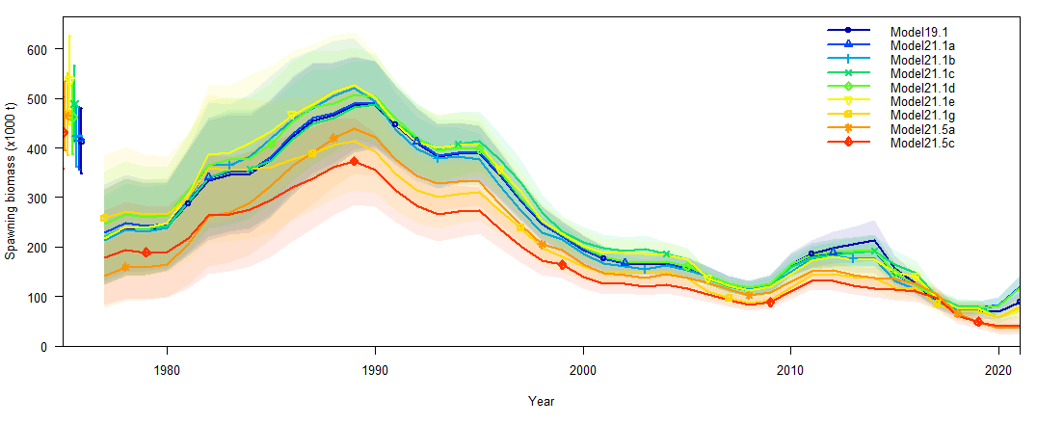

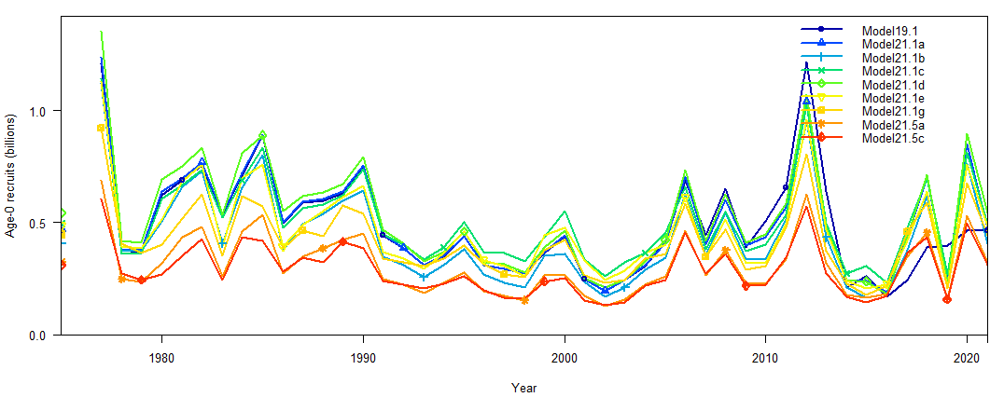

Figure 1 – (Top) spawning biomass (1000 t), and (Bottom) number of age-0 recruits (billions) for assessed models.

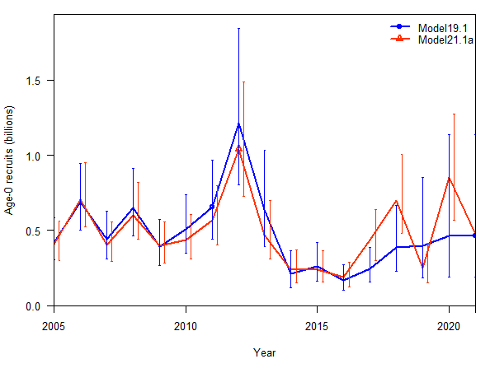 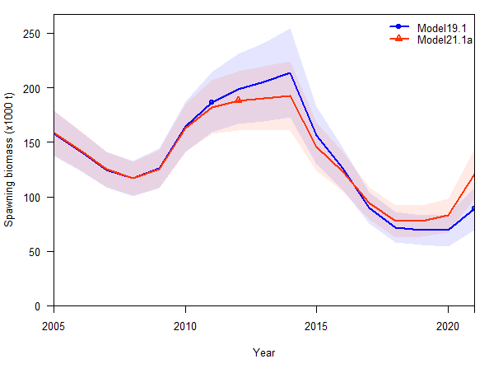

Figure 2 - (Left) estimate of the number of age-0 recruits for 2006-2021 and (Right) estimate of the 2006-2020 spawning biomass for the base model 19.1 and Model 21.1a with the inclusion of the age-0 beach seine index.

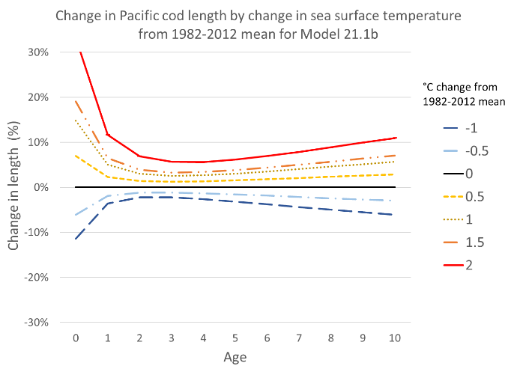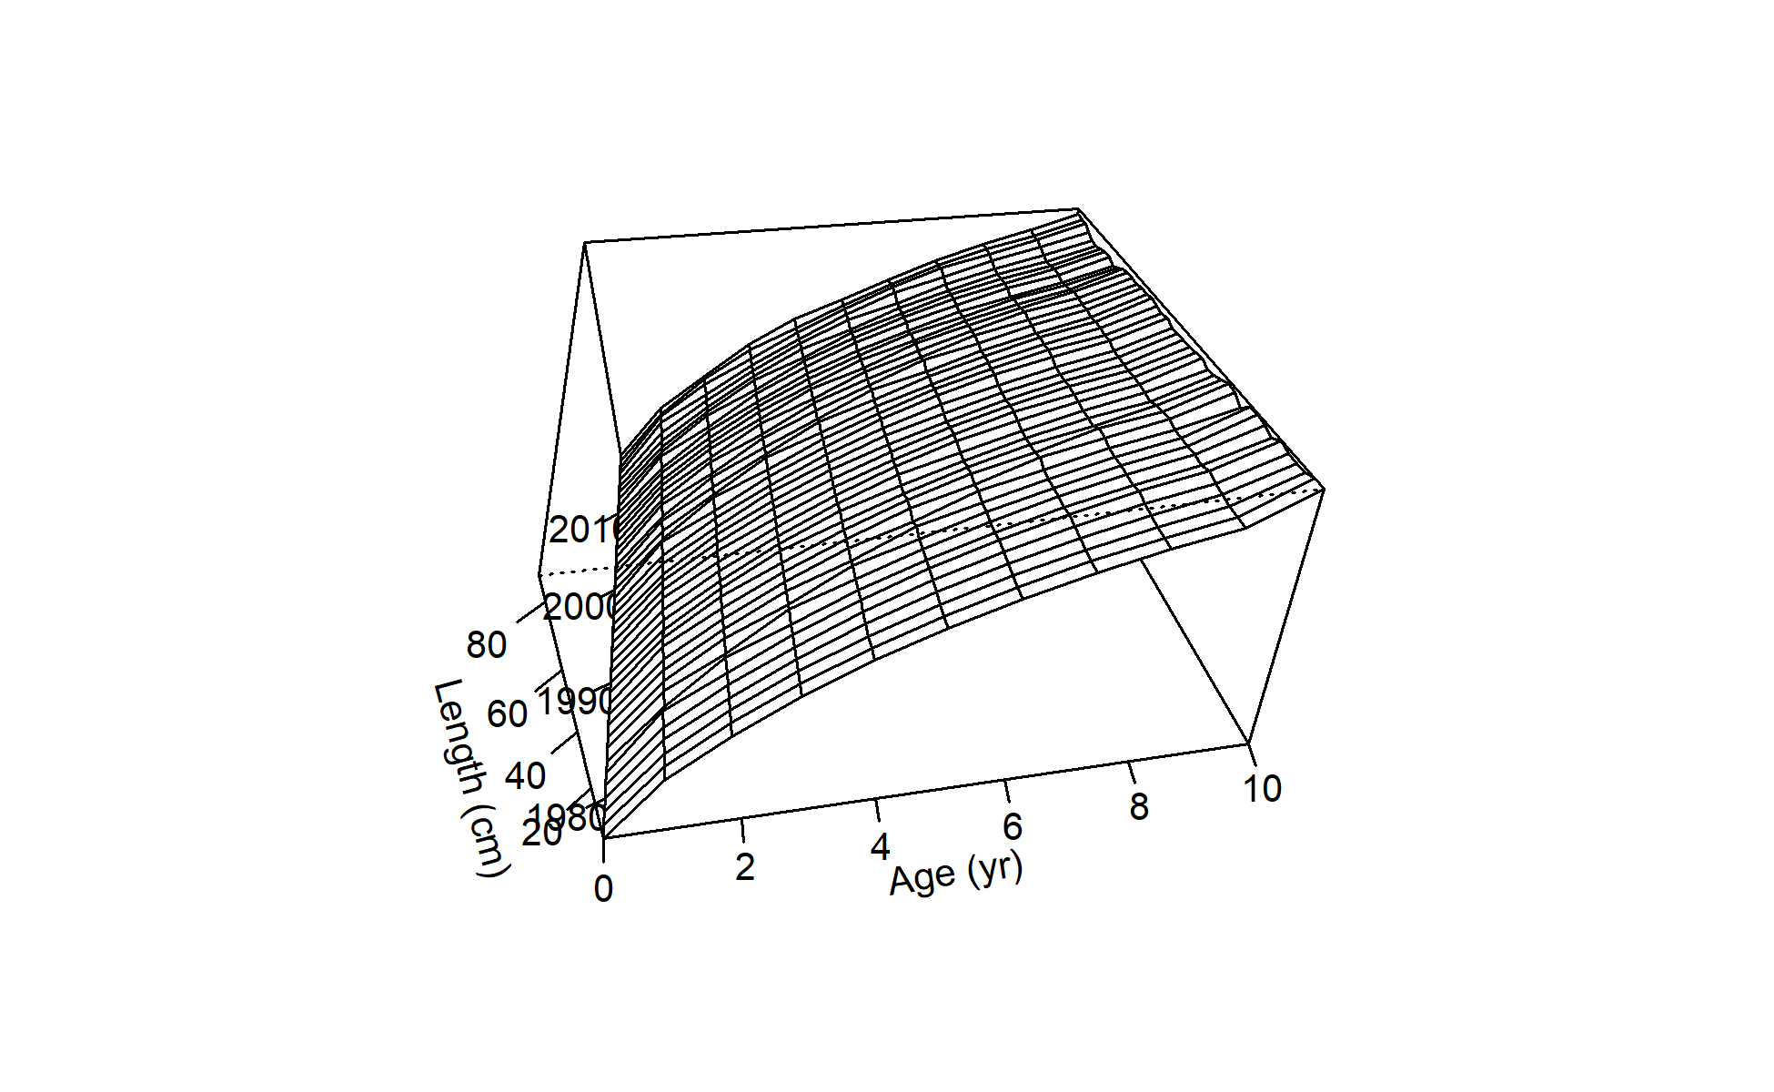

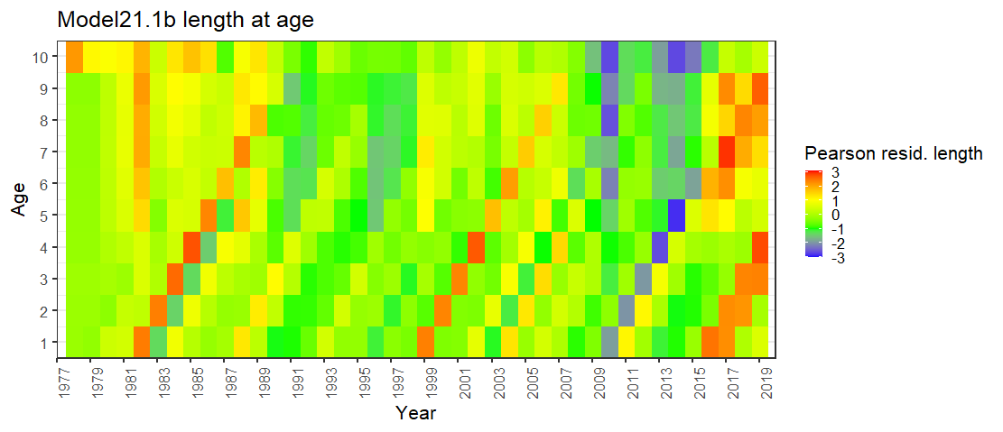

Figure 3 – For Model 21.1b (Top left) percent change in length from mean temperature by age, (Top right) Length at age over time for 1978-2020, and (bottom) Pearson residuals for length (cm) at age showing temperature effect on growth with larger Pacific cod originating in the warm years.

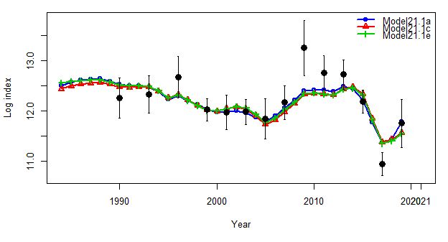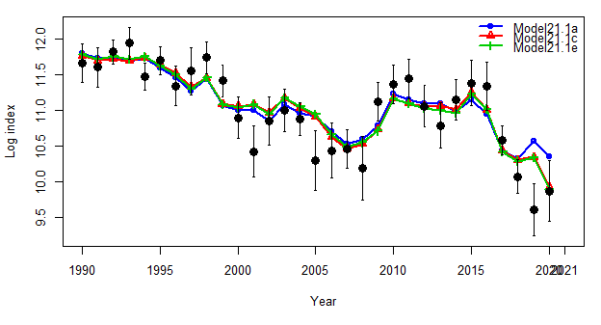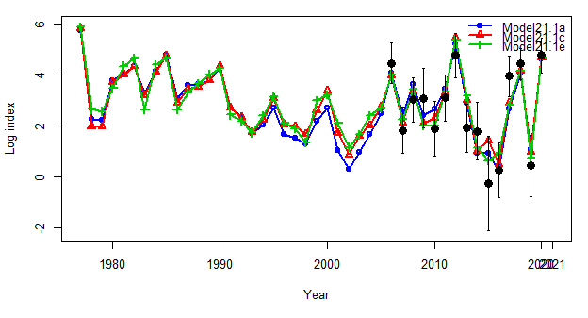

Bottom trawl survey

Longline survey

Beach seine survey

Figure 4 – Model fits to survey data for (Top left) Bottom trawl survey in tons, (Top left) Longline survey in relative population numbers, and Beach seine age-0 survey in fish per set for Model 21.1a (blue), Model 21.1c (red), and Model 21.1e (green).

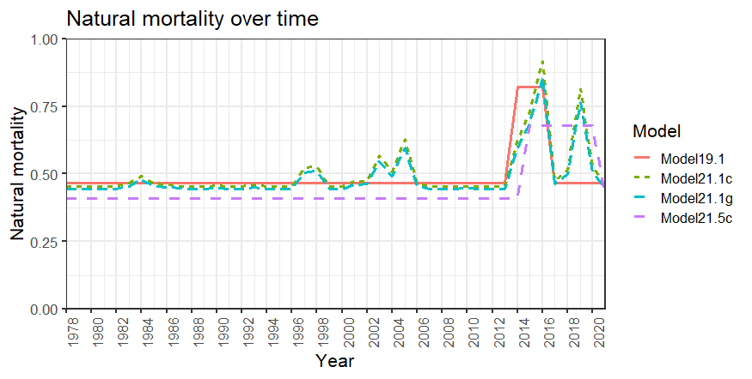

Figure 5 – Natural mortality over time for Models 19.1, 21.1c, 21.1g, and 21.5c.

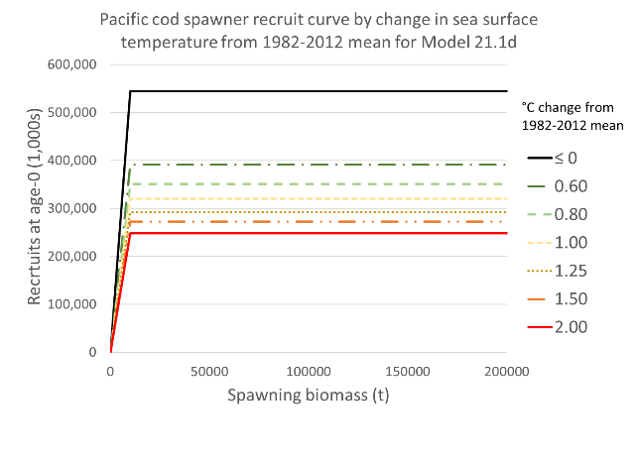

Figure 6 - Model 21.1d spawner-recruit relationship showing change over mean temperature driven by linking R0 to the spawning heatwave index. We should note here that as GOA Pacific cod remain a tier 3 stock assessment, steepness was fixed at 1.0.

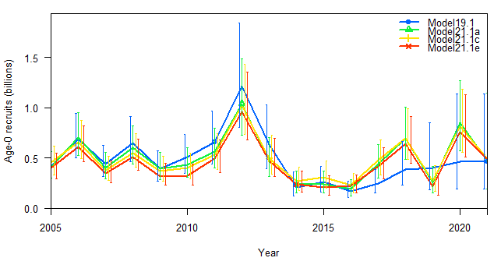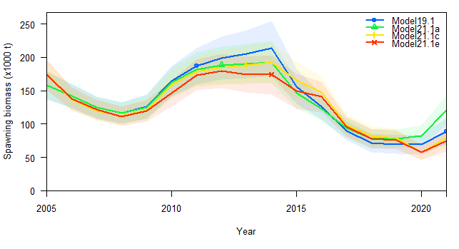

Figure 7 – (Left) Age-0 recruits and (Right) spawning biomass for 2005-2006 for Model 19.1, Model 21.1a, Model 21.1c, and Model 21.1e.

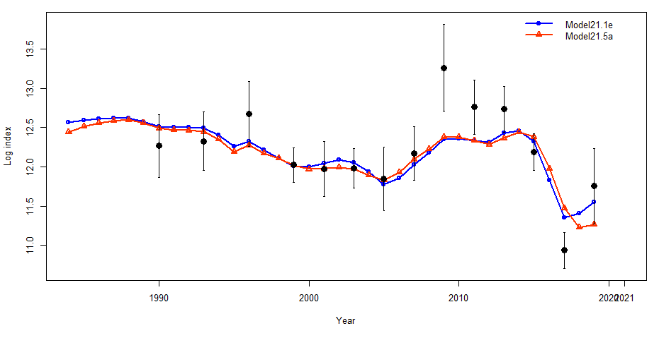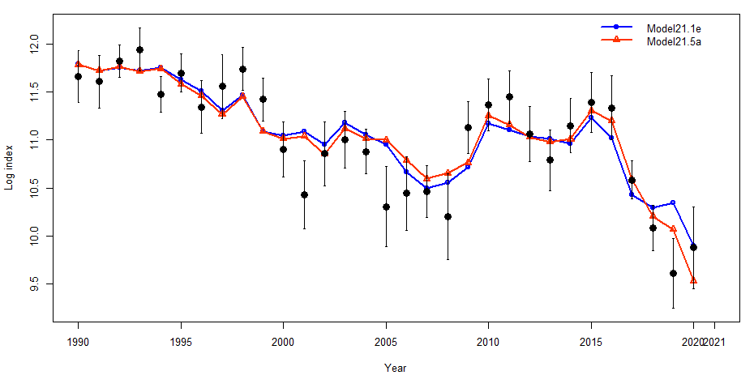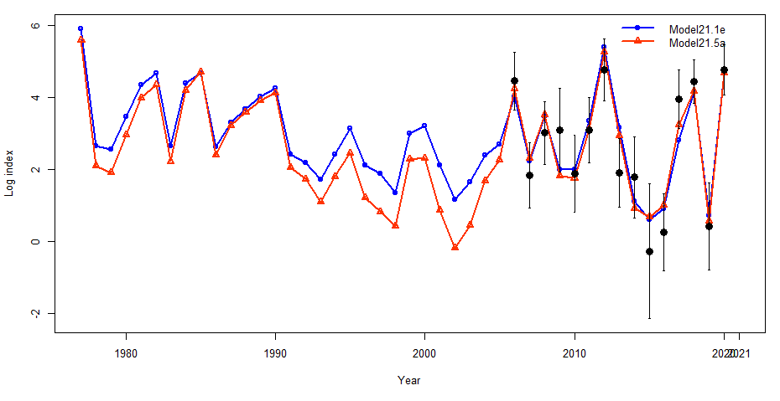

Beach seine survey

Longline survey

Bottom trawl survey

Figure 8 – Model fits to survey data for (Top left) Bottom trawl survey in tons, (Top left) Longline survey in relative population numbers, and Beach seine age-0 survey in fish per set for Model 21.1e (blue) and Model 21.5a (red).

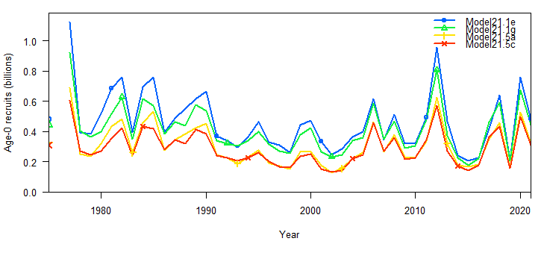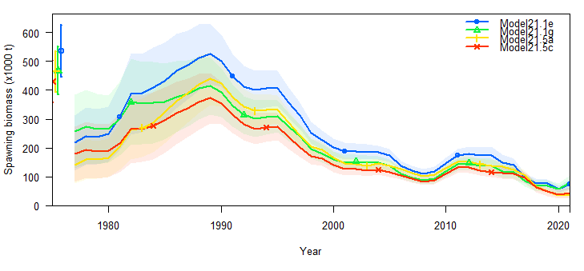

Figure 9 – (Left) Estimate of the number of age-0 recruits and (Right) estimate of the spawning biomass for 1978-2021for Model 21.1e, 21.1g. 21.5a, and 21.5c.

Model 21.1a

Model 19.1

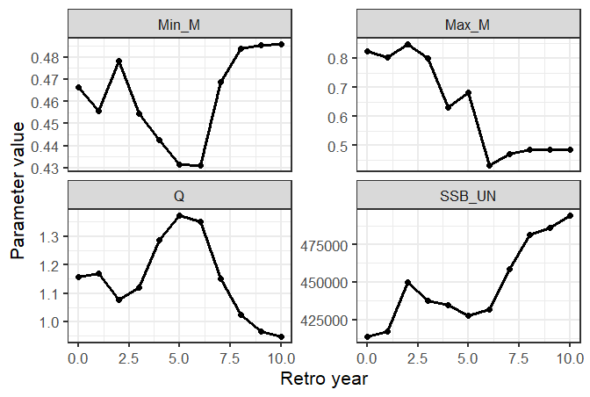 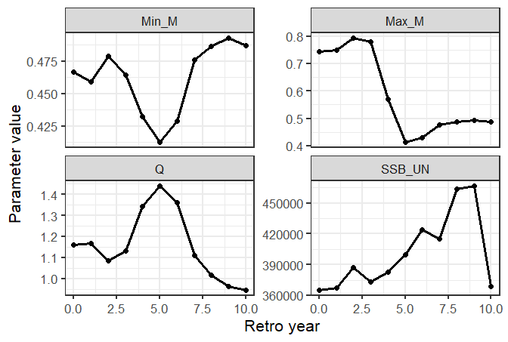

Model 21.5c

Model 21.1g

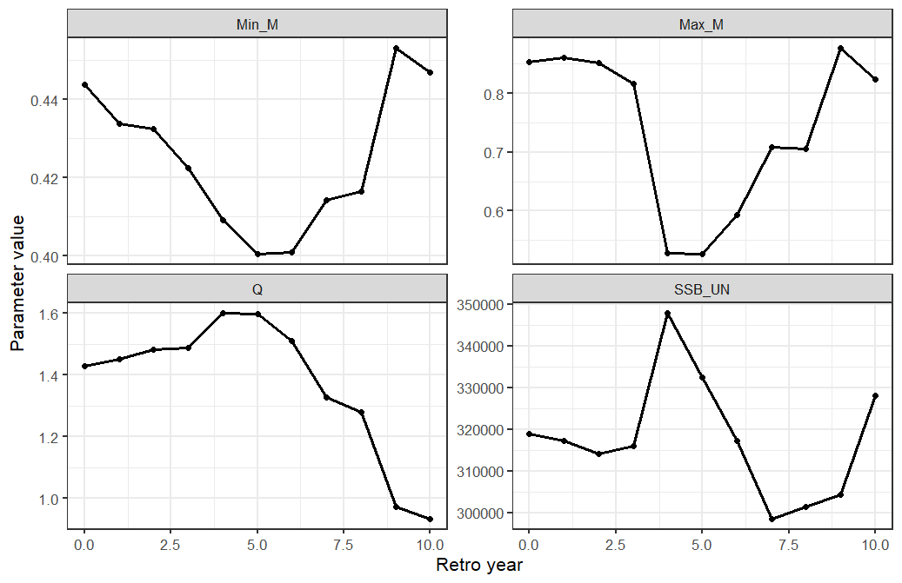 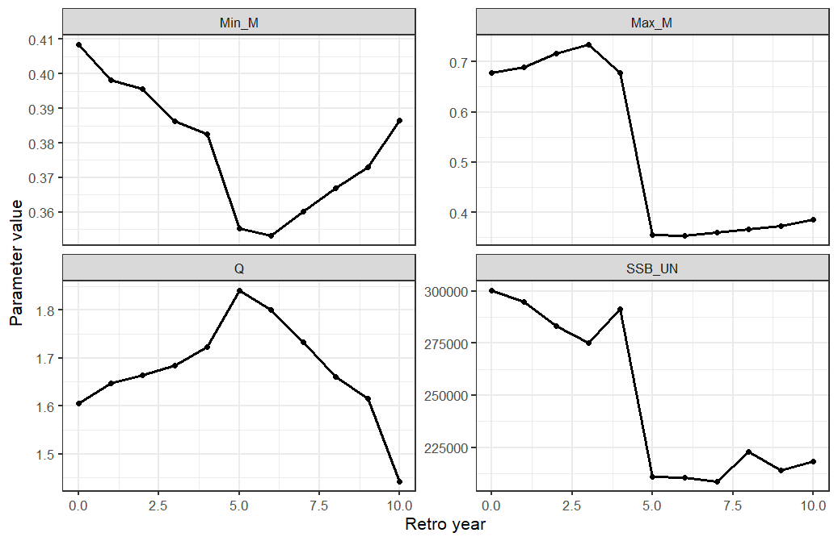

Figure 10 – Parameter values from retrospective analyses (Min_M=minumum natural mortality, Max_M=maximum natural mortality, Q = catchability, and SSB = unfished spawning biomass) for 10-year peals.

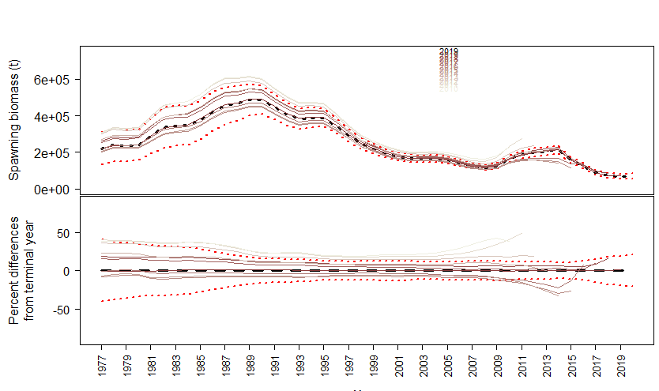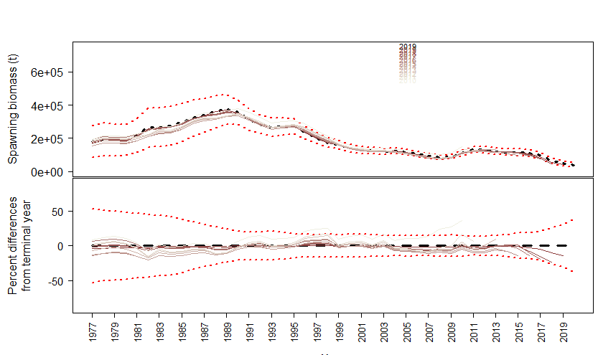

Figure 11 – Spawning stock biomass estimates from retrospective analyses for 10-year peals showing (top) spawning biomass and (bottom) percent different from terminal year for (left) Model 19.1 and (right) Model 21.5c.